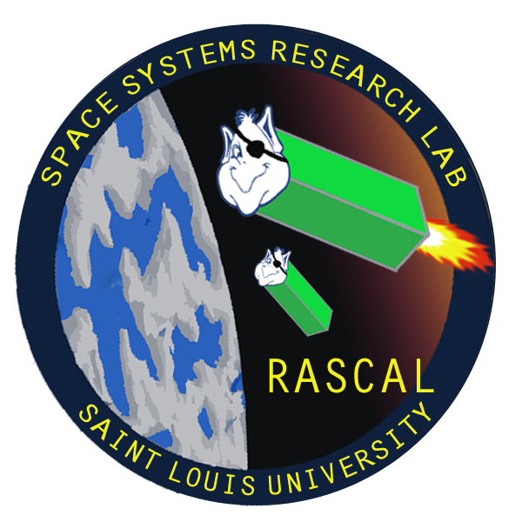

**Rascal**

Mission Overview Document

Document Number: RCL-O-CMQA2

5/6/2014

Revision: 1

|  |  |
| --- | --- |
| Prepared for:  Rascal Senior Design Review | Prepared by:  Space Systems Research Lab |

SIGNATURE PAGE

Approval:

|  |  |
| --- | --- |
| Signed by |  |
| Tom Moline | Date 5/7/2014 |
| Rascal Program Manager |  |
| Signed by |  |
| Nate Richard | Date 5/7/2014 |
| Rascal Communications Lead |  |
| Signed by |  |
| Jennifer Babb | Date 5/7/2014 |
| Rascal Structures Team Member |  |
| Signed by |  |
| Bryant Gaume | Date 5/7/2014 |
| Rascal Structures Team Member |  |
| Signed by |  |
| Tyler Olson | Date 5/7/2014 |
| Rascal Power Lead |  |

REVISION SUMMARY

|  |  |  |  |  |  |
| --- | --- | --- | --- | --- | --- |
| REV | RELEASE DATE | BRIEF DESCRIPTION/REASON FOR CHANGE | Author | Approval | EFFECTIVE PAGES |
| - | 12/09/2013 | Original Draft | TAM | NJR | All |
| 1 | 5/08/2014 | Updated for Second Semester Review | TAM | NJR | All |
|  |  |  |  |  |  |
|  |  |  |  |  |  |
|  |  |  |  |  |  |
|  |  |  |  |  |  |
|  |  |  |  |  |  |
|  |  |  |  |  |  |
|  |  |  |  |  |  |
|  |  |  |  |  |  |
|  |  |  |  |  |  |
|  |  |  |  |  |  |
|  |  |  |  |  |  |

# Executive Summary

The Rascal mission consists of a demonstration of proximity operations within the architecture of a small spacecraft, including safe navigation within a 10-50 meter distance of a target spacecraft (stationkeeping), the performance of a collision avoidance maneuver relative to the same spacecraft out to at least 100 meters, and rendezvous to within 50 meters of the same spacecraft.

The mission elements consist of two 3U spacecraft (Jade and Nephrite) that each have identical subsystems and are capable of demonstrating mission success. **Mission success is defined as demonstrating stationkeeping by maintaining a relative distance of 10-75 meters between Jade and Nephrite for at least 5 orbits, demonstrating collision avoidance by increasing the relative distance between Jade and Nephrite to at least 100 meters within 1 orbit, and demonstrating rendezvous by decreasing the relative distance between Jade and Nephrite to at least 50 meters for at least 5 orbits*.*** This will be accomplished by only necessitating one of the spacecraft to execute the mission requirements defined above, thus reducing the risk associated with flying a custom designed propulsion system into orbit for the first time.

The mission is worth pursuing as it falls within the scope of NASA’s strategic goals, specifically, those associated with demonstrating critical technologies that will make NASA’s exploration, science, and discovery missions more affordable and more capable. It will also help add to the growing amount of data on the performance of proximity operations through the use of small spacecraft, aiding in the development of such systems for use in satellite inspection and repair in the years to come.

Contents

1 Executive Summary 4

2 Program Introduction 8

3 Mission Relevance and Justification 8

3.1. Relation to NASA Objectives 8

3.2. Historical Proximity Operations Relevance 9

3.2.1. Historical Large-Scale RPO Missions 9

3.2.2. Historical Small-Scale RPO Missions 10

3.3. Related Activity in Proximity Operations 12

4 Mission Objectives 13

4.1. Baseline Mission 13

4.2. Concept of Operations 15

4.2.1. General CONOPS Overview and Definitions 15

4.2.2. CONOPS 15

4.3. Success Criteria 19

5 Requirements Verification 19

5.1. Rationale and Taxonomy 19

5.2. Mission Constraints 21

5.2.1. Launch Vehicle Integration 21

5.2.2. Mission Lifetime 23

5.2.3. Mission Success Verification 23

5.2.4. Risk Mitigation 23

5.2.4.1. Chaser Spacecraft Unable to Locate Target Object 24

5.2.4.2. Spacecraft Separation Failure 24

5.2.4.3. Propulsion System Failure 24

5.2.4.4. Collision between Target and Chaser 25

5.2.4.5. Run Out of Propellant before Mission Completion 25

5.2.4.6. Standard CubeSat Mission Risks 25

5.2.4.7. Loss of Communication 25

5.2.4.8. Spacecraft Unable to Generate Enough Power 25

5.2.4.9. Deorbit Occurs Before Six Months Has Passed 26

5.2.4.10. Launch Vehicle Causes Component Failure 26

5.2.4.11. Damage from Radiation 27

5.2.4.12. Risk Mitigation Summary 27

5.3. Requirements Verification Matrix 28

6 System Overview 32

6.1. Primary Spacecraft Overview 33

6.2. Saint Louis University Subsystems 33

6.3. Boeing Company Subsystems 34

6.3.1. Primary Spacecraft Interfaces 35

6.3.1.1. Payload-Colony-II Interfaces 35

6.3.1.2. Primary Spacecraft-Secondary Spacecraft Interfaces 37

6.3.1.2.1. Primary-Secondary Separation Mechanism 37

6.3.1.2.2. Secondary Spacecraft Power Inhibit 39

6.3.1.3. Primary Spacecraft-Ground Interfaces 40

6.3.1.3.1. Ground-Primary Spacecraft Uplink 40

6.3.1.3.2. Primary Spacecraft-Ground Downlink 40

6.4. Secondary Spacecraft Overview 40

7 Subsystem Overview 42

7.1. Attitude Determination and Control 42

7.1.1. Primary Spacecraft ADC System 42

7.1.1.1. ΔV Requirements 42

7.1.1.2. ΔV Calculation Methodology 43

7.1.1.3. Rascal Mission Test Cases 45

7.1.1.4. ΔV Analysis Conclusions 49

7.1.2. Secondary Spacecraft ADC System 50

7.2. Propulsion 50

7.3. Communications 50

7.4. Command and Data Handling 50

7.5. Ground Operation 51

8 Schedule 51

# Program Introduction

Rascal is a spacecraft mission that seeks to demonstrate the performance of in-orbit proximity operations within a small spacecraft architecture. Proximity operations are defined as the performance of orbital maneuvers, such as Stationkeeping, Rendezvous, and Collision Avoidance, relative to a resident space object (As Defined in Table 1-1).

**Table 1-1. Key Proximity Operations Definitions**

|  |  |
| --- | --- |
| **Proximity Operation Terms** | **Definition** |
| Stationkeeping | Maintaining a set relative displacement between two space objects for a period of several orbits |
| Collision Avoidance | Performing an orbital maneuver that increases the relative displacement between two space objects, as to avoid on-orbit collisions and potential orbital debris creation. |
| Rendezvous | Performing an orbital maneuver that decreases the relative displacement between two space objects within a set distance for a period of several orbits. |
| Resident Space Object | Any satellite or object residing in space |

Proximity operations have been designated by the NASA Innovative Advanced Concepts (NSPIRES) program as one of many transformative ideas that will help enable new aeronautics and space systems capabilities. If successful in demonstrating the performance of such operations, Rascal would act as a stepping stone to future development and refinement of the technologies and processes involved with the performance of proximity operations, potentially leading to the creation of small satellites that are capable of inspecting, or even repairing, damaged satellites or crew capsules, saving millions of dollars and man hours associated with the replacement of said systems that would normally have no cost-effective means of being repaired in-orbit.

This document serves to elaborate on the relevance and feasibility of proximity operations demonstrations for small spacecraft from historical, analytical, and operational perspectives, as well as outline the mission requirements, success criteria, and design flow-downs for the Rascal mission itself.

# Mission Relevance and Justification

## Relation to NASA Objectives

The Rascal mission relates directly to NASA Strategic Goal 3.3 (As Outlined in *NASA’s FY 2011 and FY 2012 Annual Performance Plans*), which states that missions should be pursued that “Develop and demonstrate the critical technologies that will make NASA’s exploration, science, and discovery missions more affordable and more capable.”

As a CubeSat mission seeking to demonstrate proximity operations that have not been performed on a system of equal scale (More On This in Section 3.2), the Racal mission meets both the requirements of demonstrating critical technologies within an affordable spacecraft system. As such, missions such as Rascal’s (Including both PONSFD and ARAPAIMA, as Discussed in Section 3.3) are highly desirable from a NASA development perspective. The reason for this rests in the potential of these types of systems to conduct inspections and maintenance on dying or decommissioned satellites, potentially saving satellite developers millions of dollars in costs associated with replacing such satellites that were previously unrecoverable.

## Historical Proximity Operations Relevance

Rendezvous and proximity operations (RPO) missions have a long history in human spaceflight dating back to the first Gemini missions. It was not until the previous decade did interest arise in approaching RPO missions with purely robotic systems. For the most part, RPO missions have been solely under the purview of NASA and the military; only recently have private companies and universities made inroads in this area. Each mission has taken a different approach to RPO and has ranged from small CubeSats to massive multi-million dollar satellites. The successes and failures of these missions have helped drive the constraints of the Rascal Mission. A summary of theses missions, as well as the success, cost, and lessons learned from their execution, are listed in Table 3-1.

## Historical Large-Scale RPO Missions

Many previous RPO missions have been large million dollar satellites, each of which approached their mission in many different ways in an attempt to demonstrate many different RPO capabilities. Out of these missions, three were selected for more analysis based on the types of RPO capabilities that they demonstrated.

The first of these spacecraft is the Demonstration for Autonomous Rendezvous Technology (DART) mission, built by Orbital Sciences Corporation for NASA in an attempt to develop and demonstrate autonomous navigation and rendezvous capabilities on a microsatellite platform. Its mission involved attempting to dock with an experimental communication satellite. The primary objectives of the mission were to navigate autonomously using GPS and rendezvous using an Advanced Video Guidance Sensor. Within a few hours of launch, it was able to reach its target, but experienced a malfunction as it began its approach, resulting in a soft collision between it and the target vehicle, which lead NASA to end the mission and begin the effort to find the cause of the malfunction. Though not publically released, the soft collision was likely a result of the chaser satellite approaching the target in a manner that the navigation algorithms used to control its propulsion system did not account for. This prevented the Advanced Video Guidance Sensor from switching to its fine tracking mode from its course mode, leading the chaser to think it was further from the target than it actually was, eventually causing the collision. The total cost of the mission was $98 million. The main lesson to take away from this mission is that even when a large amount of resources and money are used to develop and test a mission, the risk associated with its execution never completely goes away. A secondary lesson that can be taken from the mission is that the method of tracking relative position between two objects is complicated and prone to risk, thus making it a key point of investigation, development, and testing for any RPO mission.

Another mission is Orbital Express, which was built by Boeing and Ball Aerospace and managed by the Defense Advanced Research Projects Agency*(*DARPA*)* and the Marshall Spaceflight Center. The Orbital Express mission was meant to demonstrate several servicing operations as well as rendezvous and proximity operations. It consisted of two spacecraft, with one being the target and another being the servicing module. The primary spacecraft was able to refuel and replace the batteries of the target spacecraft. The total cost of the mission was $300 million. The main lesson from this mission is that demonstration of extremely complicated RPO maneuvers is possible, but requires a large amount of resources, development time, and testing, likely more than a university-class spacecraft can achieve. Thus, it is necessary to limit the scope of Rascal mission to a level where it can actually be achieved while still being able to demonstrate RPO maneuvers that are of use to the grater aerospace community.

The final large-scale spacecraft mission that was analyzed was the Micro-satellite Technology Experiment (MiTEx) mission. This mission consisted of three spacecraft working in geostationary orbit, with one serving as an experimental satellite and the other two as inspection satellites. The inspection satellites, with masses of 225 kg each, were technology demonstration satellites capable of maneuvering in relation to other satellites and providing platforms to inspect other satellites without detection. The satellites demonstrated autonomous operations, maneuvering, and station-keeping capabilities. They were built by Lockheed Martin and Orbital Sciences and managed by DARPA. They were able to complete their mission with the experimental satellite, and then moved to inspect a failed missile detection satellite to try to find the cause of the failure. The total cost of the mission was $24.6 million. The lessons learned from this mission are similar to those learned from the Orbital Express mission, with the extra edition of the usefulness of allowing for extended satellite operations when selecting the amount of propellant to fly with an RPO mission.

## Historical Small-Scale RPO Missions

More and more private institutions are starting to move into conducting RPO missions with smaller spacecraft. Currently the missions done by private institutions have been primarily proximity operations, though they still demonstrate technologies that could be used on future RPO missions.

The first of these was SNAP-1 developed by Surrey Satellite Technology Ltd and the University of Surrey. The 6 kg nanosatellite was to approach and rendezvous with Tsinghua-1, anther spacecraft that was integrated into the same launch vehicle. After launch SNAP-1 ended up in an orbit below that of Tsinghua-1 and, being relatively light, suffered more from the effects of atmospheric drag than the much heavier Tsinghua-1 microsatellite. As a result, the two spacecraft became more separated, and, at their worst, Tsinghua-1 and SNAP-1 were about 15,000 km apart. However, SNAP-1 eventually brought itself within 2000 km of Tsinghua-1 by means of propulsion maneuvers. Thus, while a true rendezvous was not achieved, SNAP-1 was able to demonstrate the agility and maneuverability of its propulsive system under automatic control. In stark contrast to the previously discussed missions, the mission cost of SNAP-1 came in at less than $1 million. This (relatively) small price tag shows that it is possible to demonstrate proximity operations within a small spacecraft architecture. However, the quick separation between the target and chaser satellite indicate that there are large risks associated with attempting proximity operations demonstrations between two spacecraft that enter orbit with even slightly different initial conditions. In terms of the Rascal mission, it is absolutely necessary to mitigate this risk to the fullest extent possible, which can be accomplished by launching with a target object connected to an interceptor, with each of them separating only upon command from the ground. This would help reduce the uncertainty associated with the initial conditions of the mission itself.

The next mission looked at was Aerocube-4, which was developed and operated by the Aerospace Corporation. It consisted of 3 1U CubeSats that each had solar panel wings that closed and opened in an attempt to alter the ballistic coefficient (Relation That Indicates the Effect of Drag on a Given Spacecraft) of each spacecraft, thus allowing for efficient formation flying (Maintenance of Small Relative Distances Between Each Spacecraft). Each satellite included three-axis attitude control to 1 degree absolute accuracy, a 0.3-square-meter deployable deorbit device, and sub-miniature reaction wheels. The satellite also carried a launch environment data logger that recorded ascent accelerations, vibration, pressure and temperature. In order to efficiently manage the formation of each spacecraft, a new three-node automated ground system network was developed. High-precision orbit determination (OD) was made possible by a GPS receiver installed on each satellite that collected fixes on a regular basis and delivered the measurements of the satellites’ position and velocity. The ultimate cost of the mission was around $200,000. Lessons learned from this mission include the importance of knowing and recording the exact location of spacecraft conducting RPO missions, whether accomplished by position/velocity motion sensors, GPS, or ground based tracking, and that high precision formation flying (or stationkeeping) can be accomplished through the implementation of relatively simple attitude control systems.

The final mission looked at was DRAGONsat, a partnership between University of Texas-Austin and Texas A&M. It consisted of two 1U spacecraft, one developed by UT Austin (PARADIGM) and the other one developed by Texas A&M (Aggiesat2). They were each deployed at the same time, with an objective of collecting two orbits worth of GPS data to determine how far apart the spacecraft separated from each other. The mission was ultimately a success and data was collected from both satellites on the general change in relative displacement between each of the spacecraft. The mission cost around $100,000. The lessons learned from this mission include further demonstration of the reliability and usefulness of GPS data for proximity operation missions.

Though other RPO missions beyond the ones discussed here have been conducted after the past 10-15 years, none have approached the demonstration of RPO maneuvers in the manner that the Rascal mission is set out to demonstrate. DART may have demonstrated the use of image navigation for rendezvous, while SNAP-1 showed the potential of CubeSat sized propulsion systems for relative position changes, and Aerocube-4 proved that stationkeeping can be maintained when precise satellite location tracking is made available, no single spacecraft mission has attempted to address each of these issues and more in the way that Rascal seeks to demonstrate for the costs typically associated with developing a CubeSat mission. Figure 3-1 consists of a comparison of the weight of a given RPO mission vs the cost associated with its development and launch, as well as whether or not each mission was considered a success.

Weight vs Cost Chart.tif

**Figure 3-1. Comparison between the Cost, Mass, and Success of Historical RPO Missions**

As can be seen from the figure, Rascal falls into a nice gap between its small-scale CubeSat and large-scale microsatellite and military satellite RPO mission counterparts of the past. It carries the benefit of having a low price tag associated with its development, as well as being able to demonstrate proximity operations the types of which have not been seen on such a small scale, with the foresight gained from previous mission failures and successes going into its mission design. Even with these missions in mind, there is still a large amount of risk associated with the Rascal mission itself. However, the historical perspective provided by each of the discussed missions offers great insight into how exactly these types of missions can fail, and thus, what part of the mission to focus on in this early development stage.

**Table 3-1. RPO Mission Summaries and Lessons Learned**

| **Mission Name** | **Institution** | **Satellite Type** | **RPO Demonstrations** | **Cost** | **Success** | **Lessons Learned** |
| --- | --- | --- | --- | --- | --- | --- |
| DART | NASA | Micro | Rendezvous | $98 Million | No | RPO Missions Have Many Failure Modes, Navigation Algorithms Must be Robust |
| Orbital Express | DARPA | Military | Rendezvous, Refueling, Component Exchange, | $300 Million | Yes | Mission Scope As a Factor of Available Resources is Important |
| MiTEx | DARPA | Military | Inspection, Station Keeping, Rendezvous | $28 Million | Yes | Extended Operations Can Demonstrate as Much Use as Primary Mission |
| SNAP-1 | SST | CubeSat | Rendezvous | $1 Million | Partial | Initial Conditions are Important in Determining the Success of a Low-Cost RPO Mission |
| Aerocube-4 | Aero Corp | CubeSat | Stationkeeping | $200 Thousand | Yes | Position Tracking is Crucial in a Successful RPO Mission, Useful Maneuvers can be Demonstrated with Small Spacecraft |
| DRAGONsat | UT Austin/ Texas A&M | CubeSat | Position Tracking | $100 Thousand | Yes | Spacecraft Separation can Occur Quickly Even with Similar Initial Conditions |

## Related Activity in Proximity Operations

Several private institutions are developing RPO missions using the CubeSat architecture while getting funding from NASA to do so. Each of these potential missions was studied as to differentiate Rascal from the back and further justify its flight. Also, based on the types of problems that these particular missions are attempting to address can help identify areas of the Rascal mission that will need to be focused on in the future, as well as those that need to be further reviewed.

The first mission that was considered was the Proximity Operations Nano-Satellite Flight Demonstration (PONSFD) mission that is currently under development by Tyvak Nano-Satellite Systems LLC and sponsored by NASA Ames Research Center. It consists of a set of two 3U spacecraft and seeks to demonstrate rendezvous and proximity operations. The concept of operations of the mission will consist of simultaneous deployment from the same spacecraft, after which an initial health check will be performed on each 3U. The mission then enters its main rendezvous and proximity operations flight demonstration phase. The spacecraft then enters an orbit in which it can maneuver to an initial proximity distance and maintain a set distance from the other, otherwise known as formation flying. Cube-sat one will perform rendezvous and proximity operations relative to Cube-sat two. Then the roles are reversed. The mission then enters increased and decreased range rendezvous and proximity operations scenarios. The mission ends when the spacecraft deorbit. This mission has received $17 million in funding from NASA and has the support of NASA Ames in its development, further high-lighting the interest of NASA in these types of missions. Even though PONSFD’s mission seeks to demonstrate proximity operations similar to those that Rascal seeks to demonstrate, it is in no way guaranteed to A) Launch and B) Achieve mission success. Thus, it is still worth pursuing the Rascal mission, as both its and PONSFD’s success would further support the validity of proximity operation systems on small-scale spacecraft and further advance NASA’s Strategic Goal 3.3, as discussed in Section 3.1.

The next mission that was considered was the Application for RSO Automated Proximity Analysis and Imaging (ARAPAIMA) spacecraft, under development at Embry-Riddle Aeronautical University, the University of Arkansas, and Red Sky Research LLC. Its mission consists of a 6U spacecraft that will autonomously maneuver into close proximity of a resident space object. The concept of operations of the mission begins with the ejection of the spacecraft in orbit, at which point its solar panels will be partially deployed. After this, it utilizes a sun tracker to point at the sun and completely deploys its panels, as to expose the mission payload. The vehicle then under goes orbit and system checkouts, which upon passing, allow it to approach a selected resident space object. Finally, the mission then enters science operations, which consist of proximity operations being performed relative to said object. Based on the missions discussed in the previous section, as well as the general cost associated with tracking and reaching a resident space object (Which has only previously been accomplished by MiTEx), this mission is highly resource intensive and vastly complex in comparison to most CubeSat missions. However, this mission has also received the support of NASA, further underlining the usefulness of such missions.

The final mission analysis looked into the Glint Analyzing Data Observation Satellite (GLADOS), which is under development at the University of Buffalo. GLADOS is a satellite designed to evaluate the size of space debris through the use of cameras capable of observing the reflection of light off of small-scale orbital debris, as to calculate the size, mass, shape, spin, and possibly the path that a given piece of orbital debris is on. The spacecraft has the capability to help in predicting the path of space debris several months in advance, which might prevent orbital collisions. Though not explicitly a proximity operations mission, GLADOS shows that it is possible to observe and analyze RSO’s in a statistically significant manner, potentially allowing for the use of such systems in performing proximity operations relative to another satellite.

# Mission Objectives



## Baseline Mission

**The main objective of the Rascal mission is to demonstrate rendezvous and proximity operations within a small-satellite architecture.**

There exist many ways in which this mission can be manifested: a single spacecraft can reach orbit, a single spacecraft that performs maneuvers relative to the rocket body that allowed it to reach orbit; two spacecraft that eject from the same launch vehicle and attempt to rendezvous with each other; multiple spacecraft that launch together and later separate; et cetera. Each of these missions would successfully demonstrate the mission goals as listed above, though in drastically different manners.

Thus, in order to limit the design space of the mission, it is necessary to further define the baseline mission itself. It would be ideal to define the types of maneuvers that need to be performed, as well as the types of objects that they should be performed on. A definition that includes each of these would allow greater context to the actual mission design itself.

The following mission statement attempts to capture each of these parameters:

**The Rascal mission seeks to incrementally demonstrate the capability of a small-spacecraft in performing proximity operations, rendezvous, and inspection of both a cooperating and non-cooperating resident space object.**

Though there are many other missions attempting to demonstrate similar or greater capabilities as those outlined above (Such as Tyvak’s PONSFD, Surrey’s STraND-2, and Embry-Riddle’s ARAPAIMA), Rascal is the only mission that has taken seriously the challenges associated with conducting rendezvous and proximity operation (RPO) missions of any scale and actually integrated a realistic assessment of program capability directly into its mission design.

It is from this assessment where the “incremental” part of the mission statement comes in. As opposed to seeking out another spacecraft on the same launch or going after a decommissioned spacecraft that is already in orbit, hoping that spacecraft acquisition and checkout occurs fast enough for the mission to actually be performed, Rascal will bring with it the target it seeks to perform its mission relative to. This alleviates the many risks associated with the “initial conditions” problem of orbital analysis and planning. Instead of attempting to account for the impact of perturbation forces (mainly, aerodynamic drag, third-body influences, solar-radiation pressure) on two spacecraft released at slightly different times in slightly different locations, and hoping that these initial conditions match up in a way that allow for the mission to be quickly executed, one can eliminate all the uncertainty and not start the mission until contact has been confirmed between each mission spacecraft and the ground. This allows for a more precise understanding of both where and when the mission is actually starting, which greatly increases the odds of its ultimate success.

As such, regardless of the way in which the mission will be executed, several components of the overall mission architecture will be fixed, mainly:

* **The Target spacecraft will be brought with the Interceptor**: this removes the risk of securing permission to go and inspect either another organization’s spacecraft or a company’s rocket body (as has been done in the past), as well as that of finding an object to perform inspection of.
* **The Target and Interceptor will be conjoined up until mission commencement**: this removes the problem of “initial conditions”, giving the mission operators greater control over the mission as a whole.
* **The mission will be conducted “incrementally”**: this attests to the difficulties that past RPO missions have encountered over the course of their mission life, as well as realistically assesses the risks associated with RPO missions of any scale.

With these over-arching goals in mind, it is now possible to discuss the manner in which the actual mission will be executed.

## Concept of Operations

## General CONOPS Overview and Definitions

* **RPO Demonstration**

The mission will demonstrate key RPO maneuvers, such as the ability to stationkeep at various distances from a resident space object, to rendezvous with said object, and to inspect said object using image processing, thus warranting its launch.

The mission CONOPS will use the terminology and mission phases, as described below:

* **Target Spacecraft:** spacecraft about which all RPO maneuvers would be performed.
* **Interceptor Spacecraft**: spacecraft with which all RPO maneuvers would be executed.
* **Cooperative State**: target spacecraft state in which all interceptor RPO aids are active.
* **Uncooperative State**: target spacecraft state in which no interceptor RPO aids are active.
* **Stationkeeping**: keeping a set relative distance between the target and interceptor spacecraft while maintaining as small a relative velocity as possible.
* **Inspection Stationkeeping (ISK)**: stationkeeping within 10 meters of the target spacecraft.
* **Remote Stationkeeping (RSK)**: stationkeeping at least 100 meters away from the target spacecraft.
* **Rendezvous**: the act of reducing the relative distance between the target and interceptor spacecraft.
* **Separation**: the act of increasing the relative distance between the target and interceptor spacecraft.

## CONOPS

Figure 4-1 shows a general overview of CONOPS. The defining feature of this CONOPS is that it is done in a very incremental fashion, allowing at various points for payload performance assessment, as well as for mission alteration (such as the ability to update RPO algorithms based on in-orbit observation, as opposed to relying solely on ground testing and predictions).

Thus, after initial launch, launch vehicle ejection, and checkout, the mission can be broken down into three primary phases. Mission success would be defined by meeting the first phase of the mission (RPO and Inspection Performance relative to a Cooperating Target Spacecraft), with the completion of the remaining two mission phases being contributing to secondary mission success.

**C:\Users\MR LEO\Documents\GitHub\Preliminary-Design\CMQA\ConOps\CONOPS Cases\Rascal ConOps NO Docking.tif**

Figure 4-1. Rascal CONOPS Illustration. The Concept of Operations for the Rascal mission consists of several distinct phases, mainly: Initial Separation, Imaging Payload Checkout, Continued Separation, Remote Stationkeeping, Rendezvous, and Inspection Stationkeeping. It also has two overlying states: Cooperative and Uncooperative.

## Phase 0: Launch to Checkout

Phase 0 of the mission consists of all of the standard processes that define the beginning of any spacecraft mission: Launch, Launch Vehicle Ejection, Spacecraft Power-On, Ground Acquisition, and Checkout. Each of these stages is laid out in detail in the following sections.

## Phase 0-A: Flight Vehicle Integration and Launch

This phase begins with Rascal’s integration into the flight vehicle and ends upon the flight vehicle reaching its target orbit. The main requirements associated with this phase would be ensuring that Rascal can survive the launch vehicle environment (Random Vibration Testing), as well as actually integrate into the launch vehicle (Following CubeSat deployer interface control document).

## Phase 0-B: Ejection

This phase begins with the opening of Rascal’s CubeSat deployer and ends with Rascal’s exit from its launch vehicle. The only requirement during this stage is that no deployables (such as solar panels, antennas, etc.) are released for a specified period of time (as dictated by the launch provider). And that the primary and secondary spacecraft remain conjoined.

## Phase 0-C: Power-On

This phase begins the moment that Rascal is ejected from its CubeSat deployer. It consists of the powering on of the primary spacecraft, which would include initiating satellite beaconing and attitude determination and control (ADC) systems. The secondary spacecraft would remain in its powered off state until its separation from the primary.

## Phase 0-D: Acquisition and Checkout

This phase is initiated on the ground and begins during the first pass of the Rascal spacecraft over any of its ground-based radio stations. Once satellite acquisition has been achieved, a checkout of the systems on both the target and interceptor spacecraft would be performed. This would consist of verifying battery telemetry data, solar panel, ADC, payload, and communications functionality prior to full mission commencement. Once this has been completed, Phase 0 would be considered complete and the mission would then enter Phase 1.

## Phase 1: Cooperating Mission Phase

Phase 1of the mission consists of the main portion of the mission, such as the separation of the target and interceptor spacecraft, the first testing of the image processing payload, and the performance of key RPO and inspection maneuvers. Mission success is defined by the ability to perform each of sub-sections of this mission phase, which are described in detail in the following sections.

## Phase 1-A: Orient for Separation

This phase begins with a command from the ground for the interceptor-target spacecraft combination to orient itself such that separation can occur with the optimal initial conditions determined before launch. This would help alleviate the risk associated with expending too much delta-V prior to mission execution. This phase ends when the proper spacecraft orientation has been verified from the ground.

## Phase 1-B: Command Separation

This phase begins with a command from the ground for the target and interceptor spacecraft to separate. This would occur near the beginning of a pass over Rascal’s ground network, such that successful separation could be verified. This phase would end with this verification.

## Phase 1-C: Move to Inspection Stationkeeping (ISK) Distance

This phase commences upon the initiation of separation. The interceptor spacecraft will enter its search mode, in which it orients itself in such a way that the target spacecraft enters the imaging payloads field of vision. Once the target spacecraft has been acquired, the interceptor will thrust out to its ISK distance (~10 meters) and stationkeep there until it can be verified on the ground that ISK is being performed.

## Phase 1-D: Verify ISK

Once the interceptor spacecraft has reached its ISK distance, it will perform thrust maneuvers to stay at said distance until verification of ISK has been made on the ground. This will be accomplished by either decoding beacon data that is being emitted by the interceptor at all times or by specifically querying for imaging/relative distance data during a pass over the Rascal ground station. This step helps alleviate the risks associated with rapidly separating the target and interceptor spacecraft, which could result in a rapid divergence in the relative displacement between each of them, making it impossible for each to rendezvous later in the mission.

## Phase 1-E: Command Continued Separation

After ISK has been verified, the interceptor spacecraft will be commanded to increase the relative distance between it and the target spacecraft from ~10 meters to ~100 meters, its remote stationkeeping (RSK) distance. This RSK distance constitutes a sphere of constant radius surrounding the target spacecraft, as shown in Figure 2-2.

## Phase 1-F: Verify RSK

Once the interceptor has reached its RSK distance, it will stationkeep until said separation has been verified, which will take place in a manner similar to that for verifying the ISK distance in Section 4.2.2.2.4.

## Phase 1-G: Command Rendezvous

Max Separation Distance.tif

Figure 4‑2. Remote Stationkeeping distance illustration. This image shows the maximum allowable separation distance between the target and interceptor. This distance is visualized as a sphere of constant radius surrounding the target spacecraft.

After RSK has been verified, a ground operator will command the interceptor to perform a rendezvous relative to the target spacecraft. This will constitute reducing the relative distance between the target and interceptor from the RSK to the ISK distance. Upon reaching its ISK distance, the interceptor will stationkeep until rendezvous verification can be made.

## Phase 1-H: Verify Rendezvous

After the interceptor has reached its ISK distance, rendezvous will be verified in the same manner discussed in Section 2.2.2.4. Once this has been done, Phase 1 will be considered complete, and preliminary mission success will be considered achieved.

## Phase 2: Noncooperating Mission Phase

Phase 2 of the Rascal mission is not very different from Phase 1: the visual aids will be turned off either due to the batteries dying or by a command from the ground, thus transforming the target into a noncooperating space object. As such, Phase 2 will consist of the same maneuvers as those described in Phase 1, with the same mission timer in play as in that phase. Full mission success is defined as being able to complete Phase 1.

## Phase 3: Extended Operations Phase

Phase 4 of the Rascal mission consists of extended operations, which can include performing Phases 1 and 3 until the propellant in the interceptor is depleted, using the interceptor’s imaging payload for Earth observation, or for studying the relative drift between two different spacecraft when provided with initial velocity and position information. The extended operations phase would end when both spacecraft deorbit within 1-3 years of launch.

## Success Criteria

In order to achieve full mission success, the Rascal mission shall demonstrate the performance of the following:

1. Spacecraft Rendezvous from a distance greater than 100 meters to within a distance of 10 meters relative to an RSO.
2. Downlink of a single image, and its corresponding displacement and angle data, of an RSO from a relative distance of at least 100 meters.
3. Downlink of a single image, and its corresponding displacement and angle data, of an RSO from a relative distance of at less than 10 meters.

# Requirements Verification



## Rationale and Taxonomy

Requirements Verification is the method of verifying that mission success has been fully met by a given mission. This mission success is determined by the ability of a mission developer’s design to meet a checklist of primary requirements that have been issued by a potential customer (such as NASA, Boeing, the DoD). If these top-level mission requirements are not met, it is within the customer’s judgment to determine whether or not their requirements were too strict, their desired mission is too impractical, or if their selection of mission developer is at fault. If it is the latter case, it is within the potential customer’s power to part ways with the mission developer, thus making any effort that went into the development of the mission a waste of time, money, and resources.

Hence, one of the most important portions of the preliminary stages of spacecraft mission design is properly defining mission requirements. In the case of the Rascal mission, the main source of these requirements is the Team Bravo Request for Proposal (RFP). This document describes both the type of mission that is to be attempted, as well as the success criteria associated with said mission, and thus is the main driver of mission design going forward. Implicit in these requirements is the need to remotely verify their successful completion when it comes time for the actual mission; otherwise the relevance of the Rascal mission would be moot and the rationale for its launch would be non-existent. Finally, even if the Rascal mission is designed to meet all of these requirements, and can demonstrate as much, it would be completely unreasonable for said mission to take an extended amount of time to be completed. The longer a mission takes to run out, the more resources have to be utilized in its operation and the more likely that it will experience a failure before mission success can be met. Thus, mission lifetime is a key factor in defining the mission success as a whole.

From these requirements (Known as the Top-Level Requirements) would then come all other requirements associated with designing a successful mission. Such requirements could be as simple as stating that the spacecraft must have a particular subsystem, or as specific as stating the force required to secure a bolt on the final spacecraft. Regardless, any of such requirements form a subset of one or more of the larger requirements above it.

The representation of the various types of requirements takes the form of a matrix consisting of the definition of each requirement, the method(s) with which it will be verified, the reason that such a requirement exists, and a requirement number for future reference.

There exist four different verification methods for each requirement can be verified:

1. **Test**: Requirements that necessitate some form of testing in order to be verified. Testing includes subjecting a component or system to vibration testing, verifying the amount of delta V that can be produced by the propulsion system, conducting thermal testing on the spacecraft system to verify that it can survive an on-orbit environment, etc. Each test will be documented in a testing document, which will in turn be used to verify that a particular requirement has been met.
2. **Analysis**: Requirements that can only be verified through computational analyses and not through physical measurement or testing. Requirements that fall under this category include calculating the thermal profile of the spacecraft system, determining the expected roll rates that can be achieved with its attitude determination and control system, finding the amount of propellant necessary to perform the mission itself, etc. Each analysis will have its own document associated with it that will be used to verify the successful completion of its corresponding requirement.
3. **Demo**: Requirements that involve demonstration in order to verify their successful completion. Requirements that fall under this category include showing that deployables will not be released until some amount of time after on-orbit ejection, that inhibits successfully cut power off to the entire spacecraft, and that the satellite communications system does not transmit during dispenser integration. Each demo requirement will be verified through test demonstration documentation prior to the actual demonstration of their completion before any organization that seeks to observe
4. **Examine**: Requirements that are verified through either visual inspection or physical measurement. Requirements that fall under this category include dimension constraints associated with the spacecraft’s external structure, the total mass of the spacecraft, etc. Each examine requirement will be verified though documentation supporting that the examination has been performed.

Each requirement will have one or more of these methods associated with its verification, as indicated by an X under its corresponding verification method column.

Each requirement will also have a brief rationale section associated with it. The rationale for each requirement will either be an extension of requirements higher up in the matrix or from constraints that have been imposed on the mission as a whole, as discussed in the next section.

## Mission Constraints

Mission constraints for the Rascal mission stem from many sources, ranging from limits on the physical size of the spacecraft used to complete it, the monetary restrictions associated with the development and integration of such a spacecraft, and the risk associated with its execution. Each of these constraints and more are described in detail in the following sections and are each crucial in both restricting the scope of the Rascal mission and allowing for its successful execution.

## Launch Vehicle Integration

One of the most important (and difficult) parts of any spacecraft mission is actually getting it off of the Earth’s surface and into orbit. Regardless of the work that is done preparing and developing the mission, if it isn’t able to be integrated into one of the currently available rockets, it will have no way of reaching orbit, and thus, no way of achieving its mission goal. Thus, it is key that whichever structure is designed to protect and encapsulate the spacecraft has the dimensions and mechanical interface necessary for it to be integrated into currently available satellite adapters.

Due to the shear amount of small spacecraft that have been launched over the past few decades, standards now exist for the integration of spacecraft into pretty much any currently available launch vehicle. Thus, if a mission follows any of these standards, it will be capable of integrating into a wide variety of launch vehicles without having to make any changes whatsoever in its integration method.

The type of adapter that a particular satellite architecture that a mission follows depends on the type of satellite that is to be integrated. Currently, there exist two major satellite classifications that any particular mission falls into: nano and micro-satellites.

Nanosatellite class spacecraft (AKA CubeSats) are those satellites that have a mass of under 1.33 kg per 10 cm x 10 cm x 10 cm volume (AKA, One Standard Unit, or 1U). This satellite classification was developed at California Polytechnic State University (Cal Poly) in 1999 as a means of standardizing small satellite architectures across the entire small satellite industry. This served to facilitate reduced costs and time associated with the development of small satellite missions, thus allowing for organizations that would have previously not been able to develop and launch small spacecraft (Such as Universities and Privately Funded Corporations) to launch scientifically significant, impactful, low-cost missions. Nanosatellites come in several different sizes, ranging from 1U to 6U. An example of 3U nanosatellite architecture, as defined by the *CubeSat Design Specification Document, Rev 13* is shown in Figure 5-1. Though the vertical dimension of each particular configuration depends on its type, the width of any CubeSat is limited to 100 mm, thus imposing a limit on the size that a given nanosatellite can occupy.

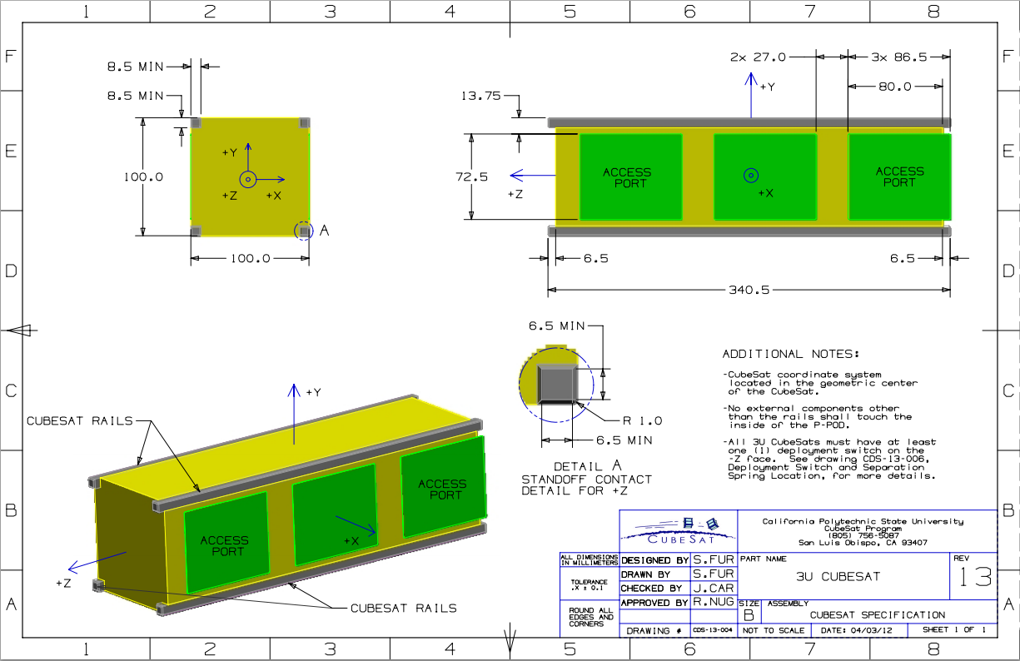

**Figure 5-1. CubeSat 3U Architecture**

Thus, for a CubeSat mission, the ultimate constraint on its launch vehicle integration is whether or not it can integrate into currently available deployers (and subsequently survive launch). Even though such deployers are similar in principal (In that they allow for the easy integration of CubeSat payloads), each deployer has different restrictions and dimensions associated with its use, as shown in Table 5-1. From this list of deployers, as well as the other constraints listed in this document, one will be selected on which to base the design of the Rascal mission as a whole.

**Table 5-1. CubeSat Deployer Fact Sheet**

|  |  |  |  |  |
| --- | --- | --- | --- | --- |
| **Deployer** | **Allowable Sizes** | **Maximum Mass** | **Specifications** | **Extra Integration Requirements** |
| P-POD | 0.5U, 1U, 1.5U, 2U, 3U | 8 kg | *CubeSat Design Specifications, Rev 13* | Separation Springs |
| CSD | 3U, 6U | 12 kg | *Payload Specification for 3U, 6U, and 27U* | Clamp Tabs |
| Wallops | 3U, 6U | 12 kg | *Wallops 6U CubeSat Deployer Specifications* | Separation Springs |
| NLAS | 3U, 6U | 14 kg | Not Available (Though Based on CDS) | Not Available |
| ISIPOD | 1U,2U, 3U | 6 kg | *CubeSat Design Specifications, Rev 13* | Separation Springs |

## Mission Lifetime

A critical component for any proximity operations mission is mission lifetime; specifically the maximum elapsed time during which the mission can be accomplished. Historical data shows that rendezvous missions are typically short or fail, with the best example being Surrey Satellite Technology Ltd’s microsat SNAP-1. SNAP-1 was intended to rendezvous with the Tisinghua-1 microsatellite after deployment from the launch vehicle’s upper stage. Though SNAP-1 carried 600 m/s in delta-V, it was not able to neutralize its velocity relative to Tisinghua-1 before the spacecraft were too far away to rendezvous. Their closest proximity was slightly less than 2000 km roughly 1.5 years after launch.

Orbital analysis corroborates the conclusion that relative velocities must be neutralized quickly after separation for rendezvous to be possible. Beyond this, though, perturbations (such as Solar Radiation pressure, Third-Body influences, and the oblateness of the Earth) lead to greater uncertainty in the position of either spacecraft relative to the other.

As such, it is important that the mission itself be executed quickly, as to reduce the risk of mission failure as much as possible. As outlined in the Mission Operations section, this would constitute a primary mission execution timeline of no more than one (1) day (or 6 passes over the Saint Louis University ground station). This puts pressure on the actual mission operators during them itself, but helps ensure that the mission is executed successfully. This timeframe also reduces the amount of effort that would have otherwise been required in ensuring that the secondary spacecraft be kept alive for months (as opposed to days) at a time, reducing overall mission complexity.

With this in mind, a minimum mission lifetime of 2 weeks for the secondary spacecraft and 6 months for the primary spacecraft has been established. The former value allows for the continuation of the mission if it were to extend beyond its planned 1 day run time. The latter value ensure that enough time is allotted for the primary spacecraft to downlink any relevant relative position and image data for analysis on the ground, which will extend beyond the scope of the primary mission itself. Each of these mission lifetimes will dictate the analyses and work necessary to ensure the survival of each spacecraft over the course of the entire mission.

## Mission Success Verification

Another crucial constraint imposed upon any spacecraft mission involves actual verification that mission success was met. This can be accomplished through the transmission of relevant science data to the ground over radio, laser communications, or through physical delivery (as was done with film canisters for surveillance satellites back in the 1960’s). In the case of CubeSat missions, radio has been the one and only way of relaying mission data to the ground, meaning that Rascal will likely utilize the same.

Once a means of relaying information to the ground has been established, it is equally important to determine what kind of information is necessary to determine mission success. In the case of Rascal, all that has to be verified is that the primary and secondary spacecraft remain set distances apart or near each other for set periods of time. This implies that each spacecraft must implement a means of collecting and storing relative distance data for downlink upon closing a link with a terrestrial communications station.

## Risk Mitigation

The final constraint to consider in the development of the Rascal mission is that of risk mitigation. As discussed in Section 3.2 and elaborated upon in Section 5.2.2.1, it is very easy for the target and chaser satellites in RPO missions to end up being vast distances apart. This risk is especially pernicious when attempting said missions within a CubeSat architecture, as any mistake involved in planning out the performance of each orbital maneuver, a failure in the operation of the propulsion system, or a glitch in the algorithms used to accomplish all of the mission’s autonomous operations can quickly lead to the development of large separations between the target and the chaser, and ultimately the failure of the mission as a whole.

Thus, it is important to identify risks associated with the development of the Rascal mission early on, as to implement design decisions that ultimately help mitigate their development. A few of these key risks are listed below, as well as the manner in which the Rascal mission will go about addressing them.

A summary of these risks, including each risk’s likelihood and consequence, can be found in Section 5.2.5.6.

## Chaser Spacecraft Unable to Locate Target Object

As discussed in Section 3.2 and Section 5.2.2.1, vast relative distances can develop between chaser and target objects in very short periods of time. This problem is compounded even more if one decides to go after an object that is already in orbit as opposed to one that is released from the same vehicle.

Thus, one way of alleviating this risk that has been attempted consists of launching both the target and chaser objects form the same spacecraft. However, as discussed in Section 3.2, this has not proven very successful. This is most likely due to the relatively long wait times associated with making first contact with and checking out any given spacecraft, which can take days or weeks. Hence, by the time said checkout is complete, and the mission is ready to begin, the target and chaser objects are already 2,000 km apart and incapable of ever achieving rendezvous ever again.

This problem can be alleviated by kicking both the target and chaser satellite out as a single unit, as opposed to two separate entities. This in turn allows for ground operators to make contact with and check out each satellite at the same time, and upon completing said process, initiate separation and begin the mission from a common starting point, thus reducing the risk associated with the two objects moving too far apart.

Hence, for the Rascal mission, it has been determined that it will consist of two separate spacecraft (Jade and Nephrite) that initially begin the mission attached to each other, as to alleviate the risk of losing the target object to the greatest extent possible (Though this does add the risk of spacecraft separation failure, as discussed in Section 5.2.5.1.1)

## Spacecraft Separation Failure

If the Jade and Nephrite do not separate properly this upon being commanded, the entire Rascal mission is at risk of failure, as it would be extremely limited in its capabilities in such a state. To mitigate this risk, ground testing will be done to make sure the spacecraft separation mechanism is working properly. Such testing would include 2-axis low friction environment testing and potentially a weightless flight on a parabolic aircraft flight (AKA, the “vomit comet”).

## Propulsion System Failure

Though many RPO missions have been developed before, only one has been demonstrated within CubeSat architecture (SNaP-1). This means that not much flight data exists on the reliability and implementation of CubeSat propulsion systems, which in turn implies that any design work that goes into such a system will have to be rigorously scrutinized and tested. However, due to this lack of historical data, the best practices and margins of safety associated with a “good” CubeSat propulsion system will not be in place, leading to the development of uncertainty in the design and manufacturing of any system that is selected

Since the only means of achieving mission success are through the successful on-orbit operation of the propulsion system that is chosen, it is critical that this risk is accounted for by any means possible. The main method of accomplishing this, beyond conducting thermal, static thrust, vibration, shock, and bake-out testing on any design that is reached, would involve giving said propulsion design two chances to succeed by having each spacecraft utilize said design.

Hence, for the Rascal mission, both Jade and Nephrite will utilize the same propulsion system, as to increase the chances of meeting mission success by giving each satellite the opportunity to conduct the mission.

## Collision between Target and Chaser

As documented by the NASA DART mission, it is possible for the target and chaser objects in RPO mission to collide, though unlikely. This risk can be mitigated through the rigorous testing of the navigation algorithms used to situate the target and chaser relative to each other, as well as through the use of differential GPS data (if possible) and inter-satellite communication to further refine this position data.

## Run Out of Propellant before Mission Completion

As discussed in Section 5.2.2.1, timing is key in executing each of the orbital maneuvers involved with the Rascal mission. Thus, there is a certain risk involved with using too much propellant to execute one or more of the maneuvers listed in Section 3.2, resulting in the loss of propellant before mission completion. This risk has already been somewhat mitigated through the inclusion of two spacecraft with propulsion systems. It can be further mitigated through the simulation of all orbital scenarios through the use of mission planning software on the ground (Preliminary software for just such testing has already been made available by Dr. Swartwout through his work on the Bandit mission at Washington University in St. Louis).

## Standard CubeSat Mission Risks

Though more specific risks to the Rascal mission (both developmental and mission related) exist, the ones listed in Sections 5.2.5.1 through 5.2.5.4 are the largest in both likelihood and consequence. Beyond those risks, however, there are inherent risks in the development on any CubeSat mission, as discussed in the following sections.

## Loss of Communication

Upon reaching orbit, if communication were to be lost with the Rascal spacecraft, neither mission success verification nor initial separation of Jade and Nephrite could be achieved, resulting in mission failure. Mitigation of this risk would involve ground testing, such as vibration testing, as well as radio signal strength and ground station capability testing.

## Spacecraft Unable to Generate Enough Power

If the Rascal power system browns out or does not have enough power to transmit data down to the ground, there would be no means of verifying mission success from the ground, the resulting in mission failure. Testing can be performed on solar panels by using a lighting system consisting of numerous full spectrum light bulbs that can replicate the suns conditions in space. Additional testing can be performed in the full function flight test with a completely integrated spacecraft with the same method. This will confirm correct power draw and use. The main means of alleviating this risk, however, would involve the creation of an accurate power budget that reflects the amount of power necessary to run the satellite and the amount that can be generated by Rascal’s solar arrays.

## Deorbit Occurs Before Six Months Has Passed

As discussed in Section 5.2.3, the mission lifetime for the Rascal mission has been set at 6 months. Thus, before any launch is accepted, the orbit that can potentially be reached by the launch vehicle through the use of orbit prediction software (Such as STK or GMAT) as to ensure that said orbit will result in at least a 6 month lifetime.

## Launch Vehicle Causes Component Failure

The main point of failure for any spacecraft is due to the vibrations and forces associated with its launch vehicle environment causing wire harness detachment or component failure. The best way to mitigate this risk is to subject Rascal to vibration testing specified by the launch vehicle that it is set to launch on. If such data is not available and testing needs to be conducted on component boards to determined the rigidity of their design, the NASA GEVS Standard Vibration Profile (As Shown in Figure 5-11) would be used in said testing’s place. This standard was developed by NASA to cover the loads and vibrations associated with any currently available launch vehicle. Thus, the results obtained from it would translate directly to any testing expected of any launch service provider.

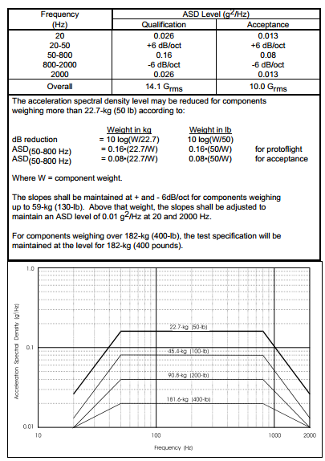

**Figure 5-11. NASA GEVS Standard Vibration Profile**

## Damage from Radiation

Inherent in any spacecraft mission is the chance that a random burst of high energy radiation from the sun happens upon a spacecraft in orbit, causing immediate failure with no proper means of recovery. Beyond incorporating radiation-hardened components whenever possible, little can be done to fully mitigate this risk.

## Risk Mitigation Summary

Table 5-2 and Figure 5-12 summarize each of the risks discussed above, as well as the likelihood and consequence of each of their occurrence.

**Table 5-2. Rascal Mission Risk Summary**

| **Risk Number** | **Risk Description** | **Likelihood** | **Consequence** |
| --- | --- | --- | --- |
| 1 | Loss of communication | 2 | 5 |
| 2 | Collision between spacecraft | 3 | 3 |
| 3 | Separation failure | 3 | 2 |
| 4 | Chaser spacecraft unable to locate target object | 3 | 4 |
| 5 | Spacecraft unable to generate enough power | 2 | 3 |
| 6 | Run out of propellant before mission completion | 1 | 5 |
| 7 | Deorbits before six months | 1 | 5 |
| 8 | Component failure during launch | 2 | 4 |
| 9 | Radiation damage | 1 | 4 |

|  |  |  |  |  |  |
| --- | --- | --- | --- | --- | --- |
| 5 |  |  |  |  |  |
| 4 |  |  |  |  |  |
| 3 |  | 3 | 2 | 4 |  |
| 2 |  |  |  | 8 | 1 |
| 1 |  |  |  | 9 | 6, 7 |
|  | 1 | 2 | 3 | 4 | 5 |

**Figure 5-12. Table of Risk Consequence vs Likelihood**

## Requirements Verification Matrix

| **Requirement** | **Verification Method(s)** | | | | **Requirement Driver** | | | **Requirement Number** |
| --- | --- | --- | --- | --- | --- | --- | --- | --- |
|  | **Test** | **Analysis** | **Demo** | **Examine** |  | | |  |
| **Top Level Requirements** | | | | | |  |  |  |
| The SSRL shall provide a payload that will be used to demonstrate Rendezvous and Proximity Operations (RPO) and Space Situational Awareness (SSA) mission capabilities. | x | x | x | x | AS&IS (Boeing) | | | RCL-RVM1 |
| **RVM1 Sub-Requirements** | | |  |  |  | | |  |
| The primary spacecraft payload shall resolve relative position and attitude data between the secondary and primary spacecraft over a range of 0-100 meters, with a maximum goal of 2000 meters. | x | x | x |  | AS&IS | | | RCL-RVM1-1 |
| **RVM1-1 Sub-Requirements** | | |  |  |  | | |  |
| The primary spacecraft shall utilize a vision system for the resolution of relative spacecraft position and attitude data. |  |  |  | x | AS&IS | | | RCL-RVM1-1-1 |
| The primary spacecraft payload shall provide navigation solutions for the position and attitude data produced by the payload vision system and Colony-II guidance, navigation, and control (GNC) system. | x | x | x |  | AS&IS | | | RCL-RVM1-1-2 |
| **RVM1 Sub-Requirements (Continued)** | | | |  |  | | |  |
| The primary spacecraft payload shall include a propulsion system for executing the RPO maneuvers outlined in the RCL-O-CMQA3 Concept of Operations document. |  |  |  | x | SSRL (SLU) | | | RCL-RVM1-2 |
| **RVM1-2 Sub-Requirements** | | |  |  |  | | |  |
| The primary spacecraft propulsion unit shall provide 3 Degrees of Freedom motion, as defined by the primary axes of its local coordinate frame. | x | x | x |  | SSRL | | | RCL-RVM1-2-1 |
| The primary spacecraft propulsion unit shall utilize cold-gas for all thrusting. |  |  |  | x | AS&IS | | | RCL-RVM1-2-2 |
| The primary spacecraft propulsion unit shall provide a total ΔV capability of 50 m/s, with a goal of 100 m/s | x | x | x |  | SSRL | | | RCL-RVM1-2-3 |
| The total volume of the primary spacecraft propulsion system shall not exceed 0.5U's (10x10x5cm) |  |  |  | x | SSRL | | | RCL-RVM1-2-4 |
| The total mass of the primary spacecraft propulsion system shall be no more than 75% of the payload mass, with a goal of 50%. |  |  |  | x | SSRL | | | RCL-RVM1-2-5 |
| **Top Level Requirements (Continued)** | | | | | | | | |
| The payload that is provided by the SSRL shall be integrated into Boeing's Colony-II bus. Together, these are designated as the Primary Spacecraft. |  |  | x | x | AS&IS | | | RCL-RVM2 |
| **RVM2 Sub-Requirements** | | | | | | | | |
| The primary spacecraft payload shall conform to the CubeSat Design Specifications Rev 12 |  |  | x | x | AS&IS | | | RCL-RVM2-1 |
| The total volume of the primary spacecraft payload shall be no greater than 1.5U's (10x10x15cm) |  |  |  | x | AS&IS | | | RCL-RVM2-2 |
| The total mass of the primary spacecraft payload shall be no greater than 3 kg. |  |  |  | x | AS&IS | | | RCL-RVM2-3 |
| The average power draw of the primary spacecraft payload shall be no greater than 10 Watts (W). | x | x |  |  | AS&IS | | | RCL-RVM2-4 |
| The peak power draw of the primary spacecraft payload shall not exceed 30 W. | x | x |  |  | AS&IS | | | RCL-RVM2-5 |
| The primary spacecraft payload will utilize the RS422 protocol for data communication between it and the Colony-II bus. |  |  | x |  | AS&IS | | | RCL-RVM2-6 |
| **Top Level Requirements (Continued)** | | | | | | | | |
| The SSRL shall provide a target resident space object (RSO) that will be used as the target object for RPO and SSA mission capabilities. This RSO will be given the designation of the Secondary Spacecraft. | x | x | x | x | AS&IS | | | RCL-RVM3 |
| **RVM3 Sub-Requirements** | | | | | | | | |
| The secondary spacecraft shall conform to the 3U CubeSat Design Specification | x | x |  | x | LSP (Launch Service Provider) | | | RCL-RVM3-1 |
| The secondary spacecraft shall be physically conjoined to the primary spacecraft prior to launch vehicle integration. | x | x | x | x | SSRL | | | RCL-RVM3-2 |
| **RVM3-2 Sub-Requirements** | | | | | | | | |
| Both the secondary and primary spacecraft shall integrate into the same 6U CubeSat Deployer. |  |  | x | x | SSRL | | | RCL-RVM3-1-1 |
| **RVM3 Sub-Requirements (Continued)** | | | | | | | | |
| The secondary spacecraft shall be physically conjoined to the primary spacecraft during launch. | x | x | x | x | SSRL | | | RCL-RVM3-3 |
| **RVM3-3 Sub-Requirements** | | | | | | | | |
| The method used to conjoin the secondary and primary spacecraft shall withstand the loads associated with the launch vehicle environment, as specified by the LSP or by the Proto-Qualification NASA GEVS Random Vibration Profile. | x |  |  |  | LSP | | | RCL-RVM3-2-1 |
| **RVM3 Sub-Requirements (Continued)** | | | | | | | | |
| The secondary spacecraft shall be physically conjoined to the primary spacecraft during launch vehicle separation. | x | x | x | x | SSRL | | | RCL-RVM3-4 |
| **RVM3-4 Sub-Requirements** | | | | | | | | |
| The secondary and primary spacecraft shall withstand an instantaneous impulsive load associated with at least a 2 m/s change in velocity, with a goal of 3 m/s. | x | x | x |  | SSRL | | | RCL-RVM3-3-1 |
| **RVM3 Sub-Requirements (Continued)** | | | | | | | | |
| The secondary spacecraft shall be physically conjoined to the primary spacecraft during initial on-orbit operations for at least 1 month, with a goal of two months. | x | x | x | x | SSRL | | | RCL-RVM3-5 |
| The secondary spacecraft shall physically separate from the primary spacecraft upon command from the ground. |  |  | x | x | SSRL | | | RCL-RVM3-6 |
| **RVM3-6 Sub-Requirements** | | | | | | | | |
| The secondary and primary spacecraft shall separate with a relative speed no more than 1 m/s, with a goal of 5 cm/s. |  |  | x | x | SSRL | | | RCL-RVM5-1-1 |
| The secondary shall separate from the primary spacecraft with a local slew rate no more than 10 ⁰/s, with a goal of 1 ⁰/s. |  |  | x | x | SSRL | | | RCL-RVM5-1-2 |
| **RVM3 Sub-Requirements (Continued)** | | | | | | | | |
| The secondary spacecraft shall remain in a powered off state until separation. |  |  | x |  | SSRL | | | RCL-RVM3-7 |
| The secondary spacecraft shall provide navigation aids to the primary spacecraft, as specified in the RCL-O-ADC1 ADC Overview document. |  |  | x | x | SSRL | | | RCL-RVM3-8 |
| **Top Level Requirements (Continued)** | | | | | | | | |
| After separation, the secondary spacecraft shall have an operational life of at least two weeks, with a goal of one month. | x | x | x |  | SSRL | | | RCL-RVM4 |
| The primary spacecraft shall have an operational life of at least 6 months, with a goal of 3 years. | x | x | x |  | AS&IS | | | RCL-RVM5 |

# System Overview

As defined by the Requirements Verification Matrix, the Rascal mission will be executed by two spacecraft: one serving as a target (or secondary) spacecraft on which proximity operations and rendezvous will be performed by a chaser (or primary) spacecraft. Each of these spacecraft will conform to the 3U CubeSat architecture, with 1.5U’s of space within the Primary Spacecraft (PSC) being provided by the Boeing company (power, communications, command and data handling, and attitude determination and control) and the rest (propulsion, image processing, and navigation algorithms) being provided by Saint Louis University. The Secondary Spacecraft (SSC) is designed to be as simple as possible while still allowing the PSC to perform and execute the Rascal mission. Up until the commencement of the primary mission, both spacecraft will be conjoined, as to reduce the risk of the spacecraft separating to a point of no return (as happened with the STRAND-1 mission) prior to spacecraft acquisition and checkout. Though this greatly reduces the risk associated with mission operations, it greatly increases the structural complexity of each spacecraft, necessitating the development of a conjoinment and separation mechanism into the design of each spacecraft. However, based on previous mission history, this precaution is absolutely necessary if the Rascal mission is to have a chance to succeed.

A functional block diagram of the entire Rascal system is shown in Figure 6-1. Though it appears that the SSC contains more subsystems than the PSC, it is important to note that many of the PSC’s basic functions, such as power management, communication, and data management, are handled by the portion of the spacecraft labeled “Boeing”. Besides this disclaimer, this diagram serves as a starting point for the detailed analysis of each section of the mission, as described in the Subsystem Overview section.

Rascal Functional Block Diagram.tif

**Figure 6-1. Rascal Functional Block Diagram**



## Primary Spacecraft Overview

The PSC consists of a 3U CubeSat structure that is capable of conjoining to the SSC. The PSC serves as a test-bed on which to demonstrate the RPO and inspection maneuvers outlined in the mission overview. The subsystems that make up the PSC are split into two separate groups: those that are set to be developed by Saint Louis University, and those by the Boeing Company. As such, it is necessary to define all interfaces between each half of the spacecraft, as to ensure a proper understanding of the functionality of the spacecraft.

## Saint Louis University Subsystems

The SLU potion of the PSC consists of cold-gas propulsion unit capable of providing up to 50 m/s of Delta-V (ΔV) over the course of the mission. This propulsion unit will be capable of providing 3 Degrees of Freedom (DOF) motion (forward-backward, left-right, up-down) and will be controlled by a separate thruster firing circuit. This circuit will receive commands from a separate image processing system, which takes in image data collected from the imaging system (a visible-spectrum, 640x480 pixel, 30 frame per second camera) and local spacecraft orientation data (collected from Boeing’s attitude determination and control sensors), and, through the use of navigation algorithms developed by Saint Louis University, determines the thruster firings necessary to keep the PSC on its pre-defined mission profile. Each of these subsystems makes up the PSC’s “payload”, and is required to fit within a 1.5U volume.

## Boeing Company Subsystems

The Boeing portion of the PSC consists of the power (PWR), communications (COM), attitude determination and control (ADC), and command and data handling (CDH) subsystems will each be housed within the remaining 1.5U volume of space and be provided by the Boeing Company. Collectively, these subsystems form the Colony-II bus. The performance characteristics and limitations of the Colony-II are listed in Table 6-1. Each accommodation/characteristic relates directly to the design of both portions of the spacecraft, and are thus critical in the overall mission design.

Table 6‑1. Colony-II Performance Characteristics/Accommodations

| **Parameter** | **Payload Accommodation/Space Vehicle Performance** |
| --- | --- |
| Design Life | 1 to 3 Years |
| Payload Mass | Up to 3 kg (Per 1.5U) |
| Payload Power | The Payload power is highly dependent on the vehicle and mission CONOPS parameters, especially mission attitude control. For solar inertial attitudes, nominal Payload power can be 20W operating with a 50% duty cycle. Peak power excursions of up to 30W can be accommodated. For LVLH attitude, continuous 10W (OAP) is nominally available for the Payload. Payload power will be re-evaluated based on selection of the solar array configuration, mission orbit, and vehicle attitude during mission operations |
| Payload Electrical Power Interfaces | 9.7V-12V unregulated, 5V regulated, 3.3V regulated |
| Payload Size | Up to 1.5U (10cm x 10cm x 15cm) |
| Pointing Control | 0.42 deg |
| Pointing Knowledge | 0.31 deg |
| Agility | Up to 3.0 deg/sec |
| Radiation Environment | Rad hard for LEO total dose for 3 years, SEU tolerant |
| Launch Environment | CubeSat GEVS standard |

## Primary Spacecraft Interfaces

An interface is defined as any structure (either physical or mechanical) that either connects or passes information between different spacecraft subsystems, different spacecraft, or a spacecraft and the ground. For the PSC, these interfaces consist of those between the Rascal Payload (provided by SLU) and Boeing’s Colony-II bus, as well as between the PSC and the SSC, and finally the PSC and the ground. These interfaces consist of three major types:

1. **Mechanical -** structural interfaces that involve the physical connections between SSRL-Boeing components.
2. **Electrical –** digital/analog interfaces that involve data communication and power transmission to and from SSRL-Boeing components.
3. **Radio –** RF interfaces that involve data transmission between the ground and either the secondary or primary spacecraft.

Beyond these three designations, each interface can be broken down into three general categories: those that interface the secondary spacecraft with the primary spacecraft, those that interface the image processing/propulsion unit with the rest of the primary spacecraft, and those that interface both spacecraft to the ground.

This section will make frequent use of the coordinate system definitions laid out for 3U spacecraft in the CubeSat Design Specification (CDS), Revision 13. A visualization of this coordinate system is provided in Figure 5-1. This is the coordinate system that will be used throughout this section, unless otherwise stated.

## Payload-Colony-II Interfaces

The main interface between the Primary Payload (PLD) and the Colony-II (COL-II) bus is a D-subminiature DB-25 connector, as shown in Figure 6-2. This interface will be used for passing power from COL-II to the PLD, as well as relaying data collected by the PLD to the communications and attitude determination and control systems (ADC) provided by COL-II and data commands and ADC sensor information from COL-II to the PLD.

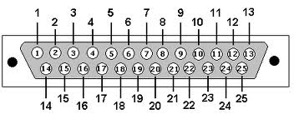

**Figure 6-2. Example DB-25 Pinout**

**Table 6-2. Primary-Colony-II Bus Interface Pinout**

| Pin Number | Pin Name | Pin Name (Shorthand) | Signal Origin |
| --- | --- | --- | --- |
|  | Live Image Data/Beacon Transmit | U1TX | PLD |
|  | Payload Data | SDA1 | PLD |
|  | COL-II Data | SDA2 | COL-II |
|  | Radio Request to Send | ~U1RTS | COL-II |
|  | Radio Clear to Send | ~U1CTS | COL-II |
|  | 5V Bus | 5V | COL-II |
|  | 3.3V Bus | 3.3V | COL-II |
|  | Ground | GND | COL-II |
|  | Ground | GND | COL-II |
|  | Unregulated | UNREG | COL-II |
|  | Unassigned |  |  |
|  | Propulsion Firing Circuit Chip Select | ~CS_PRP0 | PLD |
|  | Image Payload Chip Select | ~CS_IMG0 | PLD |
|  | SD Card Input | SDI1 | PLD |
|  | SD Card Output | SD01 | PLD |
|  | SD Chip Select | ~CS_SD | PLD |
|  | SPI Clock | SCL1 | PLD |
|  | I2C Clock | SCL2 | PLD |
|  | 5V Bus | 5V | COL-II |
|  | 3.3V Bus | 3.3V | COL-II |
|  | Ground | GND | COL-II |
|  | Unassigned |  |  |
|  | Unregulated | UNREG | COL-II |
|  | Unassigned |  |  |
|  | Unassigned |  |  |

Table 6-2 shows the pinout of the PLD-COL-II Interface. The table is organized such that each signal is given a name, designation, and origin. The baud rate for any RF data (as indicated by the TX tag) has a maximum value of 10 Mbit/s. All other data signals are nominally set to 9600 bit/s. Table 6-3 lists all of the devices that are to interface with the COL-II bus, while Figure 6-3 illustrates the data flow for all of the devices that are to be used on the Rascal spacecraft.

As can be seen from Figure 6-3, all data that runs between the Colony-II bus and the primary payload must first pass through the Primary Payload’s PIC bus. From there, signals and power are sent out to/received from each of the other devices located within the Primary Payload, including the image payload processor, propulsion system firing circuit, and data storage SD card. Said SD card will be used for storing image data (including full resolution images and their respective relative distance/quaternion data), as to allow for the later downlink and assessment of the Primary Payload’s control algorithms. These control algorithms (which are located on the image processor) will also make use of orientation data outputted by COL-II’s ADC system, thus the necessity of having a data line (SDA2) that originates from the COL-II side of the Primary Spacecraft.

Device Diagram.tif

Figure 6‑3. Rascal Spacecraft Device Dataflow

Table 6-3. Primary Payload Device List

| Device | Serial Communication Used |
| --- | --- |
| Image Payload | I2C |
| SD Card | SPI |
| Propulsion Payload | I2C |

## Primary Spacecraft-Secondary Spacecraft Interfaces

There exist two main interfaces between the primary and secondary spacecraft:

* Primary-Secondary Separation Mechanism
* Secondary Spacecraft Power Inhibit

The former interface is mainly mechanical in nature, though it will require power to be transferred from the primary to the secondary spacecraft. The latter interface is purely mechanical in nature, taking the form of a simple contact switch. Each interface is described in greater detail in the following sections.

## Primary-Secondary Separation Mechanism

The former interface is mainly mechanical in nature, consisting of two solenoids (each housed within the secondary spacecraft) that latch onto two connection points that extend from the primary, as shown in Figure 6-4. These interface points are located along the vertical center line of the Y-/Y+ faces of the Primary and Secondary Spacecraft respectively, with each point being 5 cm from the Z-/Z+ face of the secondary spacecraft respectively. Four springs will also be used in order to achieve spacecraft separation once the solenoid latches are retracted. The interface for these springs will also be located along the Y-/Y+ faces of the Primary and Secondary Spacecraft respectively, with each spring representing a corner of a 15x5cm rectangle, whose center is located at the center of the Y- face of the secondary spacecraft.

|  |  |
| --- | --- |
|  |  |

Figure 6-4. Example Drawings of Primary-Secondary Mechanical Interface. The left figure shows a magnified view of the solenoid latch interface, while the right figure shows a magnified view of the separation spring interface.

Since the secondary spacecraft is set to be off until separation, it is required that the primary spacecraft transfers power to the secondary spacecraft’s separation mechanism. This will be accomplished through the use of external electrical contact ports, one each for the Primary and Secondary Spacecraft. These ports will be at least 5V, 2.5A rated. A block diagram of this arrangement is shown in Figure 6-4. This diagram specifies that the command for separation originate from a ground station. This command is then received by the Colony-II bus COM system and passed to the Command Data Handling (CDH) system of the Primary Payload. The CDH system then interprets this command and allows for current to flow from the Primary Spacecraft, to the Power Transfer contacts, to the Secondary Spacecraft, and then directly to each of the separation solenoids. Thus, the Primary Payload’s CDH system is responsible for the actual relaying of power to the spacecraft power transfer ports, with the Colony-II bus only being required to receive and relay the actual separation command. This will involve the use of a wire harness to connect the corresponding 5V and GND ports of the CDH system to those of the power transfer port.

Separation will be verified by a contact switch located on the Y+ face of the primary spacecraft. This switch, once de-actuated, will indicate to the Primary Payload’s CDH system that separation has occurred. This information could then be queried from the ground, so that separation can be verified.

SEP Block Diagram.tif

Figure 6-5. Separation Subsystem Block Diagram

## Secondary Spacecraft Power Inhibit

The Secondary Spacecraft Power Inhibit interface is also mainly mechanical in nature, consisting of a simple switch located on the Y- face of the Secondary Spacecraft that will be compressed when the Secondary Spacecraft is conjoined with the primary spacecraft. In this state, the switch would cut off all power between the secondary spacecraft’s batteries and the rest of the secondary spacecraft, ensuring that the secondary spacecraft has enough power to remain active over the course of its 15 day mission. When the secondary spacecraft separates from the primary spacecraft, this switch will actuate to its on state, allowing the secondary spacecraft to be powered on. A block diagram of this arrangement is provided in Figure 6-6.



**Figure 6-6. Secondary Power Subsystem Block Diagram**

## Primary Spacecraft-Ground Interfaces

There exist two interfaces between each spacecraft and the ground:

* Ground-Primary Spacecraft Uplink
* Primary Spacecraft-Ground Downlink

These interfaces predominately consist of ground station antennas (located at the Space Systems Research Lab in St. Louis, MO) and spacecraft antennas. Each of these interfaces is described in greater detail in the following sections.

## Ground-Primary Spacecraft Uplink

The primary spacecraft uplink serves to command the primary spacecraft at any point in the mission. The uplink will be act the command link when the primary and secondary spacecraft are conjoined and this is how the command for spacecraft separation will be sent. The uplink data rate must be at least 4000bps and the frequency must be selected from the 430/440 MHz range. The ground station at the SSRL will act as the command station for the primary spacecraft.

A ground stations supporting the operation of the Rascal mission must be configured properly in order for the mission to be successful. Since both spacecraft will be operating in 433/440 MHz range, the ground station must have an antenna that works at that frequency and a radio that operates in that range. The TNC at the ground station must be able to send and receive GMSK modulated signals from the primary spacecraft and send FSK modulated signals to the secondary spacecraft. The TNC must support an uplink data rate of at least 1200 bps and a downlink data rate of at least 100 kbps.

## Primary Spacecraft-Ground Downlink

The primary spacecraft downlink serves to send mission and health data down to the ground. It will beacon health data down at 10 second intervals. The downlink data rate must be at least 100 kbps and the frequency must be selected from the 430/440 MHz range and use GMSK modulation. The ground station at the SSRL will act as the primary receiving station.

## Secondary Spacecraft Overview

The SSC’s main responsibility consists of aiding the PSC in performing the Rascal mission. As such, the SSC has been designed to be as simple as possible, as to alleviate the normal risks associated with operating a typical small-spacecraft mission. As such, more than 50% of its 3U volume will consists of non-rechargeable lithium batteries. These batteries, under nominal operating conditions, would be able to power the SSC for up to twenty days, which extends almost a week beyond the SSC’s minimum two week operating lifetime. The only “Payload” on the SSC consists of four external printed circuit boards (PCB), each only populated by five small light emitting diodes (LEDs). These PCB’s serve to aid the PSC’s image processing system in identifying the SSC in orbit, as well as offer a method of determining the relative distance between each spacecraft. The only other power drawing device on the SSC is a simple Radio-Frequency (RF) receiver, whose sole purpose is to receive and pass along a Payload ON/OFF command to the SSC’s single processing chip. With the limited number of devices that need to be powered on the spacecraft, a simple Electrical Power System (EPS) can be developed that consists of a single 3.3 Volt regulator that manages the powering of each spacecraft component.

These relatively small power requirements allow for the entire functional portion of the spacecraft to be contained within slightly more than 1.5U’s of space. This leaves the rest of the spacecraft open for the integration of a Nutation Damping system, whose purpose is to reduce the tumble rate of the SSC upon its separation from the PSC. This system consists of a simple arrangement of hysteresis rods and permanent magnets, which respectively aid in the detumbling and alignment of the SSC, as to aid the PSC’s image processing system in identifying the SSC.

An exploded view of the entire SSC system is shown in Figure 6-7. The spacecraft structure consists of a custom design that helps simplify the integration process. This structure will conform to the standards laid out in the CSD Rev 13, as previously discussed. The only other custom component consists of the battery pack that will be used to house each of the 27 C-Cell non-rechargeable batteries.

Exploded View Annotated.tif

**Figure 6-7. Secondary Spacecraft Annotated Exploded View**

Like the PSC, it is important to define all the interfaces associated with the design of the SSC. Besides the ones that were already covered in the previous sections, the only SSC interface that remains is that of the radio link between the ground and its COM system. This SSC uplink serves to turn off the visual aids for the primary spacecraft it is carrying. If necessary it will also be used to turn them back on. The uplink data rate must be at least 1200 bps, the frequency must be selected from the 430 MHz range, and it must be broadcast using FSK modulation l. The ground station at Saint Louis University will act as the primary command station.

A block diagram of the secondary spacecraft communication-ground interface is shown in Figure 6-8. The RF receiver consists of an RF chip and patch antenna. The purpose of this receiver is to relay an ON/OFF (6 bytes) command to the visual aids located on the external surface of the secondary payload. Thus, all COM and CDH requirements can be met with a simple RF chip and a 6 I/O-Pin PIC combination.

COM Block Diagram.tif

**Figure 6-8. Ground-Secondary Spacecraft Uplink Block Diagram**

# Subsystem Overview



## Attitude Determination and Control

The Attitude Determination and Control (ADC) subsystem is broken up between the SSC and the PSC. The main purpose of the SSC’s ADC system is to provide a way for the SSC to detumble after its initial separation from the PSC. The PSC’s ADC system involves planning out the orbital mechanics necessary for the PSC to execute the Rascal mission, calculating the ΔV involved in doing so, and developing the control algorithms necessary to keep the PSC on track. Each of these systems is described in detail in the following sections.



## Primary Spacecraft ADC System

The PSC ADC system consists almost entirely of software, as opposed to hardware, elements. These software elements include the work that went into calculating the orbital mechanics required to execute the mission, and from said mechanics, the total ΔV that would be required to do so. The process for accomplishing this is described in the following sections.

## ΔV Requirements

One of the most important parameters associated with the execution of the Rascal mission is that of the Delta-V (ΔV) required to perform each of the maneuvers associated with its mission profile, as described in each of its CONOPS. As such, the total ΔV required to perform each CONOPS was calculated. The manner in which this was accomplished is laid out in Sections 7.1.1.2 through 7.1.1.3, with the results of said calculations summarized in Section 7.1.1.4.

## ΔV Calculation Methodology

All ΔV values calculated for the Rascal mission were done so through the use of linear orbit theory. This theory effectively takes the equation of motion for a body exposed to a general gravitational field, where **r** is the inertial position of a spacecraft, $\ddot{r}$ is the acceleration of said object spacecraft, **g(r)** is the influence of a general gravitational field, and Γ is the thrust acceleration vector of the spacecraft.

(1)

CW Coordinate Frame.tif

**Figure 7-1. Illustration of the Clohessy-Wiltshire coordinate frame**

As opposed to having to analytically solving this second-order, non-linear differential equation (For which several methods and algorithms already exist), one can approximate a solution through the use of linearized equations that describe the motion of one spacecraft relative to each other. This process works well when the relative displacement between a target and interceptor spacecraft is small relative to the overall size of each spacecraft’s orbit (As is the case for the Rascal mission). Though this technique is hindered by the assumption that each spacecraft’s orbit is near-circular, it still offers a useful approximation of the expected ΔV that is to be used in a given mission.

The simplest coordinate frame to utilize for linear orbit theory analysis is that utilized by Clohessy-Wilshire (CW), as shown in Figure 7-1. This coordinate frames is spacecraft-fixed, as opposed to Earth-fixed, meaning that it rotates with the radius vector (**rinertial**) of a given spacecraft. In the case of Rascal, the origin of the coordinate frame is assigned to the target spacecraft. This means that all the relative velocities and positions discussed throughout this overview are defined relative to the target spacecraft’s CW coordinate frame, as shown in Figure 3-2. From this, the relative position between an interceptor and target spacecraft can be defined by the following equation, where **rint** and **rtgt** are the inertial positions of the interceptor and target spacecraft respectively.

CW Coordinate Frame Target Spacecraft.tif

**Figure 7-2. Relative position illustration, with secondary spacecraft as origin of CW-frame**

$$δr\left(t\right)=r_{int}\left(t\right)-r_{tgt}(t)$$

(2)

This equation can then be substituted into Equation (1), which, after quite a bit of arithmetic (As fully laid out in Prussing[1]), results in a general solution of the following form:

$$δs\left(t\right)=Φ\left(t\right)δs(0)$$

(3)

Where $δs\left(t\right)$ is defined as the 6x1 vector containing both the components of relative spacecraft position (x,y,z) and velocity ( $\dot{x},\dot{y},\dot{z})$ and $Φ\left(t\right)$ is the state transition matrix of relative spacecraft motion, which is defined as:

$Φ\left(t\right)=\left[\begin{matrix}M(t) & N(t) \\ S(t) & T(t)\end{matrix}\right]$

(4)

Where **M(t)**, **N(t)**, **S(t)**, and **T(t)** are each 3x3 matrices defined as:

$\begin{matrix}M\left(t\right)=\left[\begin{matrix}4-3c & 0 & 0 \\ 6(s-nt) & 1 & 0 \\ 0 & 0 & c\end{matrix}\right] & N\left(t\right)=\left[\begin{matrix}\frac{s}{n} & \frac{2}{n}\left(1-c\right) & 0 \\ -\frac{2}{n}(1-c) & \frac{4s-3nt}{n} & 0 \\ 0 & 0 & \frac{s}{n}\end{matrix}\right] \\ S\left(t\right)=\left[\begin{matrix}3ns & 0 & 0 \\ -6n(1-c) & 0 & 0 \\ 0 & 0 & -ns\end{matrix}\right] & T\left(t\right)=\left[\begin{matrix}c & 2s & 0 \\ -2s & 4c-3 & 0 \\ 0 & 0 & c\end{matrix}\right]\end{matrix}$

(5)

With c, s, and n in canonical units being:

$n=\sqrt{\frac{1}{r_{tgt}^{3}}}$

$$s=\sin{nt}$$

$$c=\cos{n}t$$

(6-8)

With these formulations in mind, one can finally form the general equations for the change in relative position and velocities between a target and interceptor spacecraft with time as:

$$δr\left(t\right)=M\left(t\right)δr\left(0\right)+N\left(t\right)δv(0)$$

$$δv\left(t\right)=S\left(t\right)δr\left(0\right)+T\left(t\right)δv(0)$$

(9-10)

From here, the total ΔV required to perform a maneuver that defines a new relative displacement between a target and interceptor spacecraft such that, when the interceptor arrives at said new position, the two spacecraft have no net relative velocity, can be defined as:

$∆v_{0}=N{\left(t_{f}\right)}^{-1}\left[δr\left(t_{f}\right)-M\left(t_{f}\right)δr\left(0\right)\right]-δv\left(0\right)$

$∆v_{f}=-\left[S\left(t_{f}\right)δr\left(0\right)+T\left(t_{f}\right)\left(δv\left(0\right)+∆v_{0}\right)\right]$

$∆v_{tot}=\left|∆v_{f}+∆v_{i}\right|$

(11-13)

It is this final result that was used to calculate the total ΔV required to execute each of the maneuvers laid out in the results section.

## Rascal Mission Test Cases

In order to better assess the ΔV expected to be used for the execution of the Rascal mission, several different orbit path cases were considered for various initial and final conditions, as perform a trend analysis on the affects of altering different mission parameters. The main parameters that were selected for variation were: initial relative velocity (Vrel,i), relative ISK displacement (risk), and relative RSK displacement (rrsk). Regardless of the case, it is assumed that each maneuver is performed impulsively at the moment that a previous maneuver is just being completed (implying that the initial relative velocity for each maneuver is zero) and that each maneuver takes the same amount of time to complete (in this case, 90 minutes, which is roughly the time it takes to complete one orbit).

## Low Vrel,i, rrsk and risk Both Solely in In-Track Direction

In order to assess the bare minimum ΔV required to meet the Rascal mission, a minimal ΔV test case was created. For this test case, it was assumed that the initial relative velocity between the target and interceptor during separation was minimal, and that the ISK and RSK displacements were each only in the In-Track direction relative to the target spacecraft. The results of the analysis for this case is shown in Figure 3-3, with the path of the interceptor being plotted relative to the target, where each maneuver is marked by a different color (In ascending order from blue to orange: Initial Separation, ISK, Continued Separation, RSK, Rendezvous, and Docking). The ISK and RSK distances are each indicated by black dots.

Ideal CONOPS-1 All In-Track.tif

**Figure 7-3. Relative Displacement for Case 1 between primary and secondary spacecraft for Phase 1 of Rascal’s Concept of Operations**

As shown in Table 7-1, the largest use of ΔV arises from mitigating the spacecrafts’ initial relative velocity separation, with more than half of the total ΔV usage dedicated to just that single maneuver. Also of note is the ISK and RSK ΔV values, which are effectively zero, because all spacecraft motion is kept within the In-Track direction.

**Table 7-1. ΔV Required for Low Vrel,i, rrsk and risk both in In-Track Direction**

|  |  |
| --- | --- |
| **Maneuver** | **ΔV (m/s)** |
| Initial Separation | 0.5011 |
| ISK | 0.0000 |
| Continued Separation | 0.0110 |
| RSK | 0.0000 |
| Rendezvous | 0.0110 |
| **Total** | **0.668** |

## High Vrel,I, rrsk and risk Both Solely in In-Track Direction

The next case that was analyzed was the same as that in the previous section, but with variations in the initial separation velocity. This change had to effect of increasing the ΔV necessary to counteract the initial separation velocity, but had little effect on any other ΔV requirements. These calculations were made by varying the initial separation velocity by 0.5 m/s increments along each of its principle axes. The results of these calculations are shown in Table 7-2.

**Table 7-2. ΔV Required for High Vrel,i, rrsk and risk both in In-Track Direction**

|  |  |  |  |
| --- | --- | --- | --- |
| **Initial Separation Velocity (m/s)** | | | **Total ΔV (m/s)** |
| **X** | **Y** | **Z** |
| 0 | 0.5 | 0 | **0.57** |
| 0 | 1.0 | 0 | **1.07** |
| 0 | 2.0 | 0 | **2.07** |
| 0 | 3.0 | 0 | **3.07** |
| 0.5 | 0.5 | 0 | **1.18** |
| 1.0 | 0.5 | 0 | **1.18** |
| 2.0 | 0.5 | 0 | **2.13** |
| 0 | 0.5 | 0.5 | **0.77** |
| 0 | 0.5 | 1.0 | **1.18** |
| 0 | 0.5 | 2.0 | **2.13** |

## Low Vrel,i, risk and rrsk Perturbed into Cross-Track and Out-of-Plane Direction

For this case, the initial separation velocity between each spacecraft was limited to the in-track direction, while the RSK and ISK distances were perturbed just outside of the in-line direction into both the out-of-plane and cross-track directions. Figure 7-4 shows an example of the orbital path that would be followed for this case.

Ideal CONOPS-1 RSK Pertubation.tif

**Figure 7-4. Relative Displacement for Case 3 between primary and secondary spacecraft for Phase 1 of Rascal’s Concept of Operations**

This case differs from the first two, in that, ΔV is now required in order to stationkeep. Since these stationkeep maneuvers would have to be repeated dozens of times over the course of a full mission, any increase in their magnitude has a significant effect on the total ΔV required for the mission. As shown in Table 7-3, the larger the perturbation from In-Track motion, the greater the ISK and RSK ΔV’s, and the greater the total ΔV required for the mission. However, even in a worst case scenario (being more than 100 meters off target), the total ΔV require for the entire mission offers at least a 60% fuel margin for a propulsion system capable of supplying 50 m/s of ΔV.

**Table 7-3. ΔV required for Each Maneuver for Low Vrel,I, risk and rrsk Perturbations**

|  |  |  |  |  |
| --- | --- | --- | --- | --- |
| **Maneuver** | **ΔV for Each Perturbation Case (m/s)** | | | |
| **1 m** | **5 m** | **10 m** | **100 m** |
| Initial Separation | 0.5033 | 0.5134 | 0.5288 | 1.0791 |
| ISK | 0.0067 | 0.0216 | 0.0432 | 0.4325 |
| Continued Separation | 0.0151 | 0.0323 | 0.0538 | 0.4430 |
| RSK | 0.0043 | 0.0216 | 0.0432 | 0.4325 |
| Rendezvous | 0.0069 | 0.0116 | 0.0329 | 0.4220 |
| **Total** | **0.7903** | **1.3801** | **2.2593** | **18.3775** |

## High Vrel,I, rrsk­ and risk Perturbed into the Cross-Track and Out-of-Plane Directions

For this test case, the previous case of perturbed stationkeeping distances was kept constant, while the initial separation velocity between the target and interceptor spacecraft was varied. This had an effect of increasing the total ΔV for the mission as a whole, as was the case for Case 2. Table 7-4 demonstrates this trend exactly, showing a slight increase over the values obtained for Case 2.

**Table 7-4. Total ΔV Required for Perturbed rrsk and risk, with High Vrel,i**

|  |  |  |  |
| --- | --- | --- | --- |
| **Initial Separation Velocity (m/s)** | | | **Total ΔV (m/s)** |
| **X** | **Y** | **Z** |
| 0 | 0.5 | 0 | **1.38** |
| 0 | 1.0 | 0 | **1.88** |
| 0 | 2.0 | 0 | **2.88** |
| 0 | 3.0 | 0 | **3.88** |
| 0.5 | 0.5 | 0 | **1.60** |
| 1.0 | 0.5 | 0 | **2.02** |
| 2.0 | 0.5 | 0 | **2.96** |
| 0.5 | 0.5 | 0.5 | **1.77** |
| 1.0 | 0.5 | 1.0 | **2.41** |
| 2.0 | 0.5 | 2.0 | **3.78** |

## Low Vrel,I, No rrsk or risk Perturbation, Visk Perturbation

The final test case consisted of an analysis of the affect of varying the initial relative velocity between each spacecraft at the beginning of an ISK maneuver. If there were some sort of mistiming in when a particular ISK maneuver is performed, either due to sensor error, non-impulsive thrusting, or other means, more ΔV would have to be expended in order to account for the non-zero relative velocity between the target and chaser spacecraft, as demonstrated in Table 7-5. Even for small perturbations in initial relative ISK velocity, the total ΔV for both mission increases substantially, going from 0.69 m/s to 4.97 m/s in the 0.1 m/s case. This effect only increases as the initial relative velocity value increases, having a drastic effect on the total ΔV required for the mission. However, even in a worst case scenario of missing the target velocity by 1.0 m/s on every single ISK maneuver, the propulsion system would still offer nearly a 40% margin for completing the mission.

**Table 7-5. Total ΔV Required for Perturbation in Initial ISK Relative Velocity**

|  |  |
| --- | --- |
| **Initial Relative Velocity (m/s)** | **Total ΔV (m/s)** |
| 0.1 | **4.97** |
| 0.2 | **8.07** |
| 0.3 | **11.17** |
| 0.4 | **14.27** |
| 0.5 | **17.37** |
| 1.0 | **32.87** |

## ΔV Analysis Conclusions

With each of these test cases in mind, a few conclusions can be made from the Rascal mission ΔV analysis:

1. **For an ideal mission, ΔV is a non-factor for either CONOPS.**

This statement relates to being able to execute the mission entirely in the In-Track direction. This would reduce the ΔV required to perform stationkeeping (something that has to be done for a whole day between mission phases) to zero, producing extremely high margins for the entire mission..

1. **An ideal mission is not feasible.**

This idea relates to the perturbation analysis performed in test cases three and four. For small deviations in stationkeeping displacements, large effects on the ΔV required to perform either mission are observed. If these deviations are large enough, the stationkeeping requirement between each mission phase increases to the point of making the ΔV required for the mission begin to approach its maximum value of 50 m/s.

Thus, the odds of performing an ideal mission are highly unlikely, requiring that stationkeeping would be precise enough to keep all motion in the In-Track direction. More than likely, both the geometry of a spacecraft’s orbit, as well as the influences of third-bodies, solar radiation pressure, and inaccuracies within Rascal’s control algorithms will lead to the perturbations that were discussed and studied in the later test cases. As such, it is those two cases that are most important in assessing the ΔV requirements of any form of the Rascal mission.

1. **Initial relative velocity governs all.**

As can be seen from test case two and four, small variations in initial relative velocity have a large impact on the overall ΔV required to perform any kind of proximity operation. For example, varying the RSK distance by 0.5 meters has a negligible effect on the ΔV required to perform the mission. Varying the initial separation velocity, on the other hand, can increase the ΔV required for the mission by twofold. As such, one of the most important limiting parameters on any mission (but especially for one involving docking) would be that of the initial separation velocity between each spacecraft.

1. **Timing is crucial.**

Finally, each part of this analysis assumed that each maneuver was performed at the end of the previous maneuver, implying that the starting relative velocity between each spacecraft would be zero. As discussed in the previous point, if this were not the case, the ΔV required to perform a given maneuver would increase substantially, greatly affecting the total ΔV required to perform the mission, as shown in the final test case. As such, thruster timing and maneuvering are crucial in limiting the ΔV required for any mission.

## Secondary Spacecraft ADC System

The secondary Attitude Determination and Control subsystem was designed to be simple to cut down on power draw and in turn extend mission lifetime. A nutation damping system of hysteresis rods and a permanent magnet were selected. There are several environmental torques that the secondary spacecraft have overcome in order to stabilize. There is the gravity gradient torque due to the gravitational pull from Earth. Then there is the torque from solar radiation that the spacecraft would experience in space. Finally, the atmosphere still exerts a torque at the 300 km altitude and that needs to be accounted for. A root sum square was taken to find the average, which is used to find the magnetic dipole needed to create a control torque ten times that of the root sum square of the other environmental torques. That result is used to find a magnet strong enough to exert a magnetic torque ten times greater than the environmental torques the secondary spacecraft will experience. The results of this analysis is shown in Table 7-6, which consists of the torques the spacecraft will experience and the magnetic torque a magnet will need to exert.

**Table 7.6. Secondary Spacecraft Nutation Damping Characteristics**

|  |  |
| --- | --- |
| **Torque Sources** | **Torque** |
| Gravity Gradient | 5.88E-07 Nm |
| Solar Radiation | 7.22E-09 Nm |
| Aerodynamic | 1.09E-06 Nm |
| Magnetic Dipole Requirement | 2.55 Am2 |

## Propulsion

The propulsion (PRP) subsystem is responsible for the performance of each orbital maneuver necessary to achieve mission success. As described in the System Overview, only the PSC will utilize a propulsion system during flight. This system must be capable of integrating into the Colony-II bus, and will be controlled by commands issued by the image processing system.

The current design utilizes R134-A as a propellant with the Lee EPSV two-way solenoid valves and separates the propulsion unit into two 3d-printed components: a thruster assembly and a tank assembly. The tank’s maximum capacity is 0.2837 kg of liquid propellant (quality of 1) under 5.65 atmospheres of pressure.

In order to provide accurate translational control, it is necessary to have the thrusters as close as possible to the spacecraft’s center of mass. This presents a challenge in that the interface between the Colony-II bus and the payload must then pass through the propulsion unit to connect, potentially increasing piping complexity and reducing tank capacity if the thruster and tank assemblies were structurally joined as a single unit. Separating the two assemblies circumvents this issue by placing the thruster assembly directly on top of the Colony-II bus and the tank assembly on top of the payload. The two assemblies are connected by a fuel line. Figure 1 shows a proposed layout of the primary spacecraft with the separated tank and thruster assemblies.

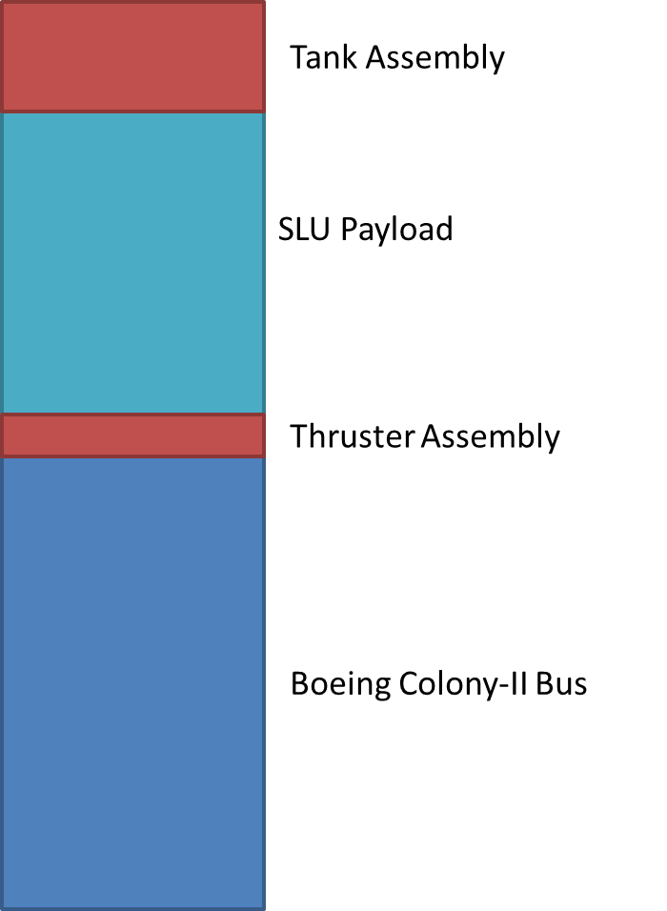

**Figure 7-5. Proposed Rascal Primary Spacecraft layout.**

The tank assembly consists of two major structures: the main tank and the expansion chamber. Assuming that the propellant is under high pressure, the expansion chamber ensures that the propellant is a gas before it reaches the thrusters. An expansion valve separates the main tank from the expansion chamber and a control valve isolates the tank assembly from the thruster assembly. Figure 7-6 shows a functional block diagram of the propulsion subsystem.

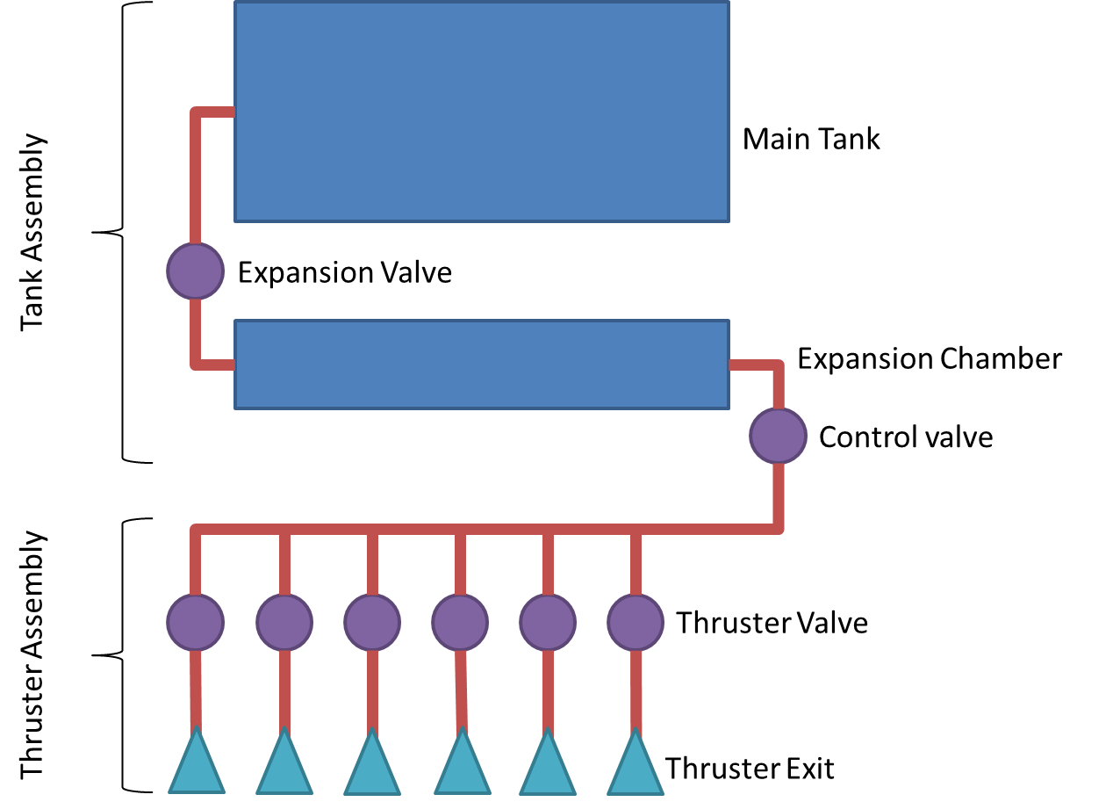

**Figure 7-6. Propulsion Subsystem Functional Block Diagram**

The thruster assembly consists of the six control valves, one for each direction of motion, connected to two thruster blocks and is compatible with the standard CubeSat bus. Each thruster block is flush with the spacecraft structure and has six thrusters, allowing for the required three degrees of freedom. Figure 7-7 shows the thruster placement on a thruster block, and Figure 7-8 shows the positioning of the thruster blocks on the 3U spacecraft.



**Figure 7-7. Thruster Block Detail**

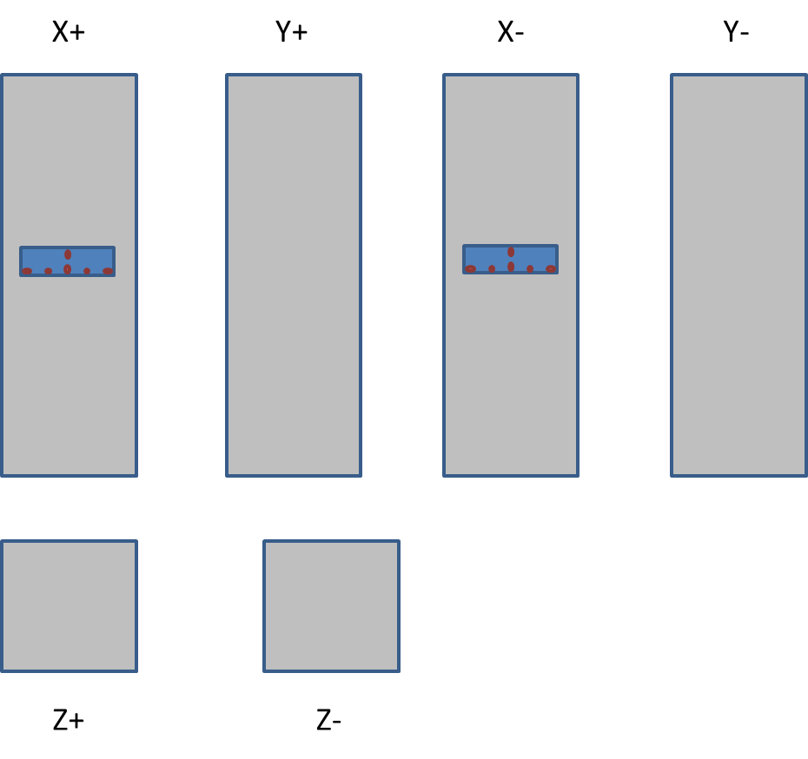

**Figure 7-8. Thruster Block Positioning**

Figures 7-9 and 7-10 each show the preliminary engineering drawings of the thruster and tank subassemblies respectively. All measurements shown are in centimeters, and both subassemblies adhere to the CubeSat standard.

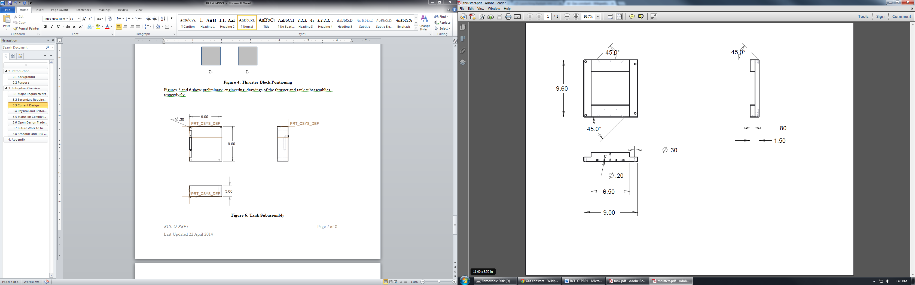

**Figure7-9. Thruster Subassembly**

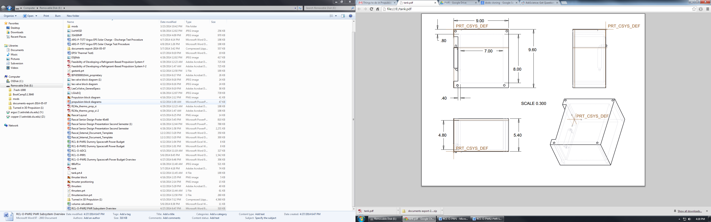

**Figure 7-10. Tank Subassembly**

The propulsion subsystem shall be designed to conform to the requirements proposed in the Requirements Verification Matrix and Concept of Operations. These requirements were used to calculate the required mass of propellant and the corresponding propellant volume necessary to conduct the mission, as shown in Table 7-7.

**Table 7-7. Propellant Characteristics**

|  |  |  |  |  |  |  |  |
| --- | --- | --- | --- | --- | --- | --- | --- |
| Liquid Density  (kg / m^3) | Saturated vapor Pressure @ 20 °C (kPa) | Specific Impulse (s) | Required ΔV + 15% Margin (m/s) | Spacecraft Wet Mass (kg) | Spacecraft Dry Mass (kg) | Propellant Mass (kg) | Propellant Volume (cm^3) |
| 1150 | 572 | 48.5 | 35.0 | 4.00 | 3.72 | 0.284 | 250 |

## Communications

The communication subsystem provides a method of verification for the completion of each mission phase. It also provides a way to maintain communication with the primary spacecraft and serves as a means to power on and off the LEDs on the secondary spacecraft. Data sent over the RF link would be relative distances and velocities, images from the payload, and primary spacecraft health. Boeing is providing the communication subsystem on the primary spacecraft and the communication subsystem on the secondary spacecraft consists of an RF receiver and patch antenna.

The primary spacecraft will be sending down relative distances and velocities, images from the payload, and primary spacecraft health and a communication system to support the transfer of that data. The radio will be operating in the 430/440 MHz range using GMSK modulation. The uplink data rate will be at least 4000 bps and the downlink data rate will be at least 100 kbps. Knowing the health of the spacecraft is important, so data such as battery voltage, temperature data, solar panel current, etc. will beacon down periodically. Based off historical data and experience, finding a CubeSat early in its mission can be difficult, so the beacon interval will be no more than 10 seconds to make it an easy target to listen for.

The RF link between the secondary spacecraft and the ground is much simpler. One command needs to be sent to the secondary spacecraft to power the navigation aids on and off. An RF receiver on the secondary spacecraft will listen for a command sent from the ground. The receiver will operate in the 430 MHz range and use FSK modulation.

## Command and Data Handling

The Command and Data Handling (CDH) subsystem is responsible for making on-orbit decisions, processing health sensor data, and managing data during downlink. The CDH subsystem will handle the images from the payload and the relative distances and velocities calculated by the payload system. It will also handle all health data and any commands that come from the ground.

**CDH Block Diagram.tif**

**Figure 7-12. PSC Command and Data Handling Block Diagram**

Figure 7-12 shows how the CDH system will interface with payload. Every 1.25 seconds, a picture will be saved to an SD card, with relative distance and angle data will be saved to the same SD card every 1 second. This allows for said information to be downlinked and analyzed after the completion of the primary mission, as to assess the validity of the control algorithms used for navigating the PSC relative to the SSC.

Based on this information, a data budget for the PSC was calculate, as shown in Table 7-9 below. From this table, one can see that the majority of the data produced by the PSC consists of images captured by the image processing system. This data generation was estimated with a 30 fps camera that took 640x480 pixel images with 8-bit color. The amount of time over which data was set to be collected related to the amount of time that would be required to executed the primary mission. To accomplish this, the mission was split into three parts: ISK, which occurs twice, one at the beginning, and one at the end of the mission, Transition, which also occurs twice, once from ISK to RSK and once from RSK to ISK, and RSK, which occurs once. Each of these maneuvers were assumed to take 90 minutes, and the camera was assumed to be operating over the entire course of the flight.

Once the memory necessary to store said data was calculated, the final result was competed to the 16 GB of memory that is available for storage. It was determined that this method of data generation resulted in a margin of greater than 25%, allowing for more data to be collected if the mission extends beyond the data collection period.

**Table 7-9. Primary Spacecraft Data Budget**

|  |  |  |
| --- | --- | --- |
| **Mission Segment** | **Duration (min)** | **Data Generated (GB)** |
| ISK | 180 | 4.158 |
| Transition | 180 | 4.158 |
| RSK | 90 | 2.079 |
|  | **Total** | **10.39** |
|  | **Margin** | **5.61** |

The secondary spacecraft CDH is much simpler. It would the voltage to the radio and LEDs by providing 3.3V. It also handles the power cycle command for the LEDs. The system would be a microcontroller and a voltage regulator. Since the RVM does not include any requirements relating to the transmission of information from the SSC to the ground, no mission data is being recorded to the SSC, and thus, no data budget was created for it.

## Power

In order to ensure that the Rascal spacecraft has enough power on orbit to complete the science mission, each subsystem was analyzed on a component-by-component basis. Because the duty cycle of the components varies between operational modes, each subsystem was also analyzed to take into account the duty cycle of each component throughout the orbit.

In the case of the primary spacecraft, the SLU payload is allotted a constant 10 watt draw from the Colony-II bus, with a maximum draw of 30 watts. A power budget was constructed to ensure that the SLU primary payload meets these requirements.

For the secondary spacecraft, it was decided that solar arrays and a rechargeable battery array was too costly. Instead, the secondary spacecraft will leverage its excessive mass and volume margins for a large, non-rechargeable battery array. A power budget was constructed to determine how much power would be consumed during the different operational modes and used to determine how much battery capacity would be necessary to operate the secondary spacecraft for a minimum of 14 days. This information was then used to select a battery.

## Primary Spacecraft Power System

Before a detailed analysis can be made of the power necessary to operate the primary payload, it is first necessary to list the assumptions made in its construction:

* Four operational modes: stationkeeping rendezvous / escape, separation, and acquisition.
* During acquisition mode, the SLU payload will be mostly powered off with only the CDH subsystem active.
* During separation mode, thrusters will be firing a maximum of 15% of the time.
* During rendezvous / escape mode thrusters will be firing a maximum of 15% of the time.
* During stationkeeping mode thrusters will be firing a maximum of 3% of the time.

We’ve these assumptions in mind, a power budget was developed for the Primary Payload, as listed in Table 7-10

|  |  |  |  |  |  |  |  |  |  |  |  |  |
| --- | --- | --- | --- | --- | --- | --- | --- | --- | --- | --- | --- | --- |
|  | | | | | **Operational Mode** | | | | | | | |
| **SK** | | **RDZ/CONT SEP** | | **SEP** | | **ACQ** | |
| **System** | **Component** | **Voltage** | **Current (mA)** | **#** | **Duty Cycle** | **Power Draw (mW)** | **Duty Cycle** | **Power Draw (mW)** | **Duty Cycle** | **Power Draw (mW)** | **Duty Cycle** | **Power Draw (mW)** |
| **CDH** | Processor | 3.3 | 0.2 | 1 | 100.00% | 0.66 | 100.00% | 0.66 | 100.00% | 0.66 | 100.00% | 0.66 |
|  | | | | |  |  |  |  |  |  |  |  |
| **PLD** | FPGA / Camera | 5 | 20 | 1 | 100.00% | 100 | 100.00% | 100 | 100.00% | 100 | 0.00% | 0 |
|  | | | | |  |  |  |  |  |  |  |  |
| **PRP** | Valves | 5 | 131.58 | 8 | 3.00% | 157.89 | 15.00% | 789.48 | 15.00% | 789.48 | 0.00% | 0 |
| Fire Control Board | 3.3 | 0.2 | 1 | 100.00% | 0.66 | 100.00% | 0.66 | 100.00% | 0.66 | 0.00% | 0 |
|  | | | | |  |  |  |  |  |  |  |  |
| **Sep** | Solenoid | 3.3 | 1000 | 1 | 0.00% | 0 | 0.00% | 0 | 100.00% | 3300 | 0.00% | 0 |
|  | | | | | | | | | | |  |  |
| **Total Instantaneous Power Draw per Operational Mode (W)** | | | | | 0.26 | | 0.89 | | 4.19 | | 0.00 | |

This budget shows that no operation mode exceeds the maximum average power draw or maximum peak power draw specified in the preceding requirements, indicating that each of the payloads subsystems would be acceptable to integrate into Boeing’s Colony-II bus.

## Secondary Spacecraft Power System

Similar to the PSC, the SSC power system analysis involved various assumptions with respect to its calculation:

* 500 km orbit with an orbital period of 94.61 minutes and a maximum eclipse duration of 35.75 minutes.
* 16 completed orbits every 24 hour period.
* One CubeSat U of space masses 1.33 kg
* 1.5 CubeSat U of internal volume available for the battery pack
* Three operational modes: LEDs on, LEDs off, and Deployment
* Deployment mode will last a maximum of 60 seconds

Along with these assumptions, it is assumed that he SSC has three different operational power states: LEDs active, LEDs inactive, and deployment. Because deployment could potentially have the largest power draw, it has been assumed to be 60 seconds long (much longer than anticipated) to provide a comfortable margin. The secondary spacecraft has five components drawing power at any one time: the radio receiver, the EPS, the processor, 20 LEDs, and a solenoid for deployment.

This information was then used to develop a power budget for the SSC, as shown in Table 7-11. This information was used to size the battery pack necessary to achieve a mission lifetime of at least two weeks. The design that was selected consists of 27 C sized (50 mm in height x 26 mm diameter) 55 gram batteries connected in parallel. The batteries will be placed into a support structure to secure them inside the spacecraft and to make wiring easier. To regulate and protect the spacecraft bus, the Electrical Power System (EPS) will consist of one voltage regulator outputting 3.3V. The secondary spacecraft will not have any solar panels or power-generating ability to minimize the complexity and cost of the power subsystem.

A lithium-thionyl chloride battery which have a nominal voltage of 3.6 volts, are rated at a maximum continuous discharge of 200 m, and are operational from -60°C to 85°C was selected to power the secondary spacecraft. The batteries are primary cells, and are not rechargeable. The total power stored in the battery pack is 1166 Watt-hours (W-Hr), from which deployment will take only .077 W-Hr. The remaining 1165 W-Hr capacity will sustain the spacecraft for 35 days with the LEDs on, exceeding the one month mission lifetime goal. The characteristics of this battery pack are summarized in Table 7-12.

**Table 7-11. Secondary Spacecraft Power Budget**

|  |  |  |  |  |  |  |  |
| --- | --- | --- | --- | --- | --- | --- | --- |
|  | | | | | **Operational Mode** | | |
| **LEDs On** | **LEDs Off** | **Deployment** |
| **Subsystem** | **Component** | **Voltage** | **Current (mA)** | **Quantity** | **Power Draw (mW)** | | |
| **COM** | Radio Receiver | 3.3 | 11 | 1 | 36.3 | 36.3 | 36.3 |
|  |  |  |  |  |  |  |  |
| **PLD** | LEDs | 3.3 | 20 | 20 | 1320 | 0 | 1320 |
|  |  |  |  |  |  |  |  |
| **PWR/CDH** | Voltage Regulator | 3.3 | 0.085 | 1 | 0.2805 | 0.2805 | 0.2805 |
| Processor | 3.3 | 0.2 | 1 | 0.66 | 0.66 | 0.66 |
|  |  |  |  |  |  |  |  |
| **Sep** | Solenoid | 3.3 | 1000 | 1 | 0 | 0 | 3300 |
|  | | | | | | | |
| **Total Instantaneous Power Draw per Operational Mode (mW)** | | | | | 1357.24 | 37.24 | 4657.24 |

**Table 7-12. Secondary Spacecraft Battery Pack Characteristics**

|  |  |
| --- | --- |
| **Total Battery Pack Capacity (mA-Hr)** | 324000 |
| **Total Battery Pack Energy (mW-Hr)** | 1166400 |
| **Total Energy for Deployment (mW-Hr)** | 77.62 |
| **Energy Remaining after Deployment (mW-Hr)** | 1166322 |
| **Total Hours w/ LEDs On (hours)** | 859.33 |
| **Total Days w/ LEDs On (days)** | **35.81** |

## Mission Operations

Due to the nature of the Rascal mission, it will have to be done quickly. Once regular communication has been established with the Rascal spacecraft, separation would be initiated and then there would a limited time to complete the mission. It would be run over the course of a few days before the relative distance between the two spacecraft became too great that mission cannot be completed. Each portion of the mission will be verified on the ground before moving to the next portion. The method of validation to move to the section of the mission will be the downlinking of relative distance and angle data to verify that the appropriate distance has been reached as well as a picture to serve as verification of the distance and angle measurements.



**Figure 7-15. Ground-Spacecraft Block Diagram**

In order for a ground station to support the Rascal mission, the ground station has to meet several requirements. Since both spacecraft will be operating in 433/440 MHz range, the ground station must have an antenna that works at that frequency and a radio that operates in that range. The TNC at the ground station must be able to send and receive GMSK modulated signals from the primary spacecraft and send FSK modulated signals to the secondary spacecraft. The TNC must support an uplink data rate of at least 1200 bps and a downlink data rate of at least 100 kbps.